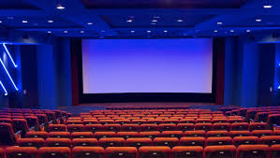

Anusha Pokharel

00175011

Computing Project

Level 5 in Computing

Softwarica College of IT and E-Commerce

Kathmandu, Nepal

7/26/2019

**PHP (Laravel Framework) with PhpMyAdmin**

Contents

**Acknowledgement** 2

**Abstract** 3

**Introduction of Project** 4

**1.1 Background of the Project** 5

**1.2 Overview of the Project** 5

**1.3 Problem Statement**:- 6

**1.4 Aims and Objectives** 6

**Scope of the project** 7

**Development methodology** 7

**Design Pattern** 9

**System Architecture** 10

**Work Break Down Structure:-** 11

**Milestone:-** 14

**Description of Milestone-:** 15

**Analysis** 16

**Feasibility Study** 18

**Requirement Analysis** 19

**Prioritization** 21

**Software requirement specification (SRS)** 23

**Use-Case** 24

**Design** 28

**Class Diagram** 28

**Flow Chart** 30

**Activity Diagram** 32

**Sequence Diagram-:** 34

**Data Base** 37

**ER Diagram** 39

**Prototyping-:** 40

**Architecture-:** 43

**Testing** 45

**RISK Management-:** 66

**Configuration Management** 68

**Project Issue** 70

**Limitation** 70

**Future Work** 71

**Conclusion** 72

**References-:** 73

**Appendix** 74

Figure 1: Water Fall Model 10

Figure 2 MVC Design Pattern 12

Figure 3:3-tier Structure 13

Figure 4: WBS structure 14

Figure 5: Tabular form of WBS structure 15

Figure 6 milestone 16

Figure 7 Use- Case Diagram 26

Figure 8 NLA 28

Figure 9 initial class diagram 29

Figure 10 final class diagram 31

Figure 11 Flow Chart 33

Figure 12 Activity Diagram 35

Figure 13 Sequence Diagram for login 37

Figure 14 Sequence Diagram for Project 38

Figure 22 E R Diagram 41

Figure 23: Protype of Home page 42

Figure 24 : Protype of Seat Chart 43

Figure 25 : Protype of Login 43

Figure 26: Prototype of Register 44

Figure 27 3-tier structure 45

Figure 28 friend request 48

Figure 83 configuration management 72

Figure 84: GANTT chart 72

Figure 85 database 77

Figure 86 Controller 77

Figure 87 database 78

# **Acknowledgement**

For this project I have taken lots of help from my module teacher. So I would like to thank my module leader. Module leader had helped and supported in the completion of my project.

Also I have taken lots of help from my friends, teachers to solve the confusing and though task. Also to those who pass me some comment to improve the quality of the project. Thus I think I have completed my project meeting the expectation of the module leader.

Anusha Pokharel

22 ‘B’

26th July, 2019

# **Abstract**

This project is created to help the customers book their ticket from online so that they should not visit to the cinema hall and stand in the queue for long time to book the ticket. This project can be used by the customers with internet connection wherever they like.

This project is name as “Movie Mandala”. In this project customer can see the ongoing movies and upcoming movie and then they can book the ticket of their movie. Customers can also book ticket for various time and select seat wherever they like. They can also watch movie trailer of their favorite movie. This project is created with the aim that they customers can save their time and also helps to save their time from being waste. Customers can find the rate of the movie while booking their ticket.

In this project there are three users like Registered User and admin whereas registered user can book ticket, watch trailer, select seat and select ShowTime and also the admin can add movie, add hall, add ShowTime, add screen and other features.

To create this project I have used waterfall development methodology in Laravel framework of 5.7 version with XAMPP and PHP my admin with MVC pattern.

# **Introduction of Project**

This project is about Online Movie Ticket Booking System which helps the customers to book the movie ticket from the house/office or any other place with the internet connection. I have create this project using the PHP Laravel framework with the PhpMyAdmin database. This project allows the customer to book their ticket with the chosen seat in any nearby theater. Customers can also watch the trailer and look for the upcoming movie.

## **1.1 Background of the Project**

Online Movie Booking System is a web application where user can book tickets for their free time with the chosen seat while being in the home or any other places with the internet connection. User can see the ongoing movies and also the upcoming movies of the theater.

This project is created using PHP with the Laravel framework and PhpMyAdmin is used for the database. User at first can register their name, address, email, phone number and many other information and they can login with their email id and password and book their tickets and select their seats. Other if the visitor visits the page they can get information from About Us and can get details of the theater or movies by contacting the phone number given in the website.

## **1.2 Overview of the Project**

Overall this website helps the user in different ways. It is useful for every users and is easy to operate. Some of the features of the website are mentioned below:

* User should Register and login to the system-:

User should register their basic information at first and then login with their username and password and create their own account.

* User should book ticket for the particular movie-:

User should book their tickets before visiting the theaters from their place and reserve their seat wherever they want.

* User can rate the movies:-

User can rate the movie after watching it.

* Users also can comment, review about the movie and website:-

User can comment about the website and the movies they have watch. User can review about the movie after watching it.

* User can watch trailer and information for upcoming movie:-

User can also watch trailer for the movie they are watching and also for the upcoming movie.

## **1.3 Problem Statement**:-

There are many problems for booking tickets for movies. People have to stand in queue for long time and cannot get wanted seat for them. People should face lot of difficulties for just booking ticket and have to spend an hours for booking. People are also unaware about the playing movies and have to visit to the theater to know about that and also they need to visit theater to know about the timing of the movie.

Problem solution are:-

* Online ticket booking helps to reduce work load
* Online ticket helps to save time.
* Online ticket booking helps people to reserve their wanted seat.

## **1.4 Aims and Objectives**

This project was developed with some aims and objectives which are mentioned below-:

**Aims**

* To provide user facilities by booking tickets from their place at any time.
* To remove numbers of staff in ticket counter.
* To help users save their time and work.
* To develop the technology and digitalize the world.
* To maintain customer satisfaction.

**Objectives**

* To manage all the activities like customer, ticket, movies etc.
* It help to manage all the information related to movies, trailers, timing, seats and many other.
* It helps the user to save their time. It helps to promote technology.
* It helps to reduce manual work of the customer.

## **Scope of the project**

* Scope

Online movies booking system is for theaters which help for storing database with information like movies date, price, upcoming movies, rating and reviews of movies and retrieve by user easily.

* Limitation of the Online Movie Ticket Management system are mentioned below:-

User should pay their bills after visiting the theater. Payment system from online is not available in this system.

* Overview of the Scope:-

Overview of scope is to provide the users proper facilities through the website by saving their time and effort. Technology have a huge scope in the current situation. Thus I have use technology to help customer.

## **Development methodology**

For this project I have used waterfall model. Waterfall model is mostly used in the software development methodology. Waterfall model is used in this project as in waterfall model teams can step toward other task only after the completion of the first task. It might take long period but it is flexible for this project. Waterfall model contains 6 steps like analysis, design, development, testing, deployment and maintenance.

Every step is followed accordingly. At first analysis is done that is every information of the organization is gathered and used in the design phase. And with the information of analysis, design of the project is drawn accordingly. After the design team members are engaged in working with the development phase of the project. Testing is followed by development, as testing of the newly developed project is done. After testing, final arrangement of the project is done that is deployment and for the last phase maintenance of the project is done.

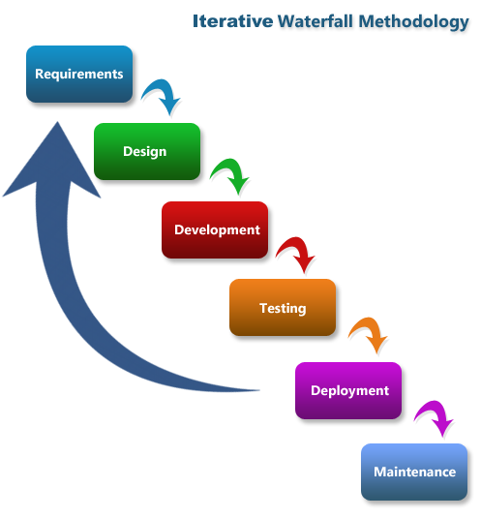

Figure 1: Water Fall Model

Thus, I have used Waterfall development Methodology in this project for some valid reason which is mentioned below-:

* It is very simple to understand and user-friendly.
* Waterfall model helps with the overlapping of the task created due to multitasking.
* Waterfall model would be very easy to develop the small project.

Every steps of the waterfall model is described in a detailed way following-:

1. Analysis

Analysis phase of the waterfall development methodology helps to collect information from the particular organization/company which would be helpful while development of the project.

1. Design

After the completion of analysis phase design is created for the project according to the information gathered.

Design is also one of the important phase of software development.

1. Development

After the design of project, development phase is performed in which the coding part is performed. This phase takes the longest period of the time among all the phase

1. Testing

Testing of any time of the project is necessary to check the functions developed in the development phase is working successfully or not. This phase is most important phase. Each function of the project is tested before handling the project to the clients.

1. Deployment

Deployment phase is mandatory as deployment of the system according to the client’s requirement is done.

1. Maintenance

Some problems or bugs may arise in the deployment phase which should be fixed in the maintenance phase. Every function of the project should be maintained before handling to the clients.

## **Design Pattern**

In this project I have used Model View Controller (MVC) design pattern. Design patterns helps to solve the problem repeatedly. Design pattern cannot be converted into the code as it is not a finished design. I have used MVC pattern in this project as MVC pattern is most popular framework in the development methodology.

Here I have used MVC design pattern for the following reasons like:

* MVC pattern helps in quick development.
* MVC pattern provides multi view of the project
* MVC pattern ensure that modification cannot affect the project
* MVC pattern do not format the data before returning.
* MVC pattern is an arranged way to place the code of model, view and controller.

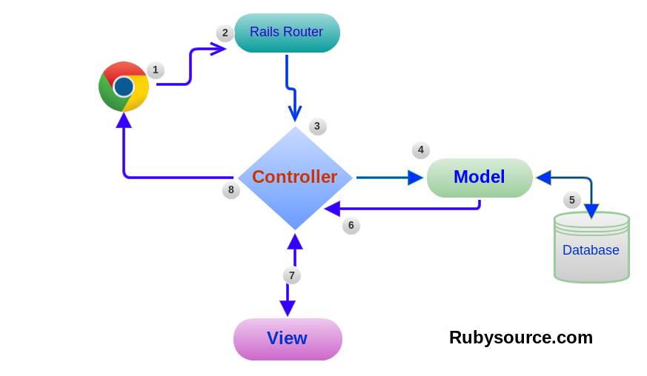

Figure 2 MVC Design Pattern

* Model:

Model of the MVC pattern is responsible for all the logic related data. It also contains the data provided between controller and view.

* View

View from the MVC pattern is responsible for the outlook of the project. It contain the code responsible for the design of the system. It handles UI of the system.

* Controller

Controller from the MVC pattern is responsible for the mediatory between model and view and also to process upcoming request and logic.

## **System Architecture**

System architecture defines structural views, behavioral views and many other views of the system. It is also defined as the conceptual model. It explains the representation as well as the formal description of a system. For this project I have used 3-tier structure.

A 3-tier structure also a type of software architecture formed by layers and tiers and also of logical computing

The reasons why I have choose 3-tier structure is described below:

* Maintainability: All tiers of the 3-tier structures are independent to each other.
* Scalability: Every tier in the structure can be changed accordingly when needed.
* Flexibility: Every tier of the structure maintains flexibility and can be managed independently.
* Reusability-: Every tier’s elements can be reused over a time.
* Faster development-: Task are completed in short time due to work division.

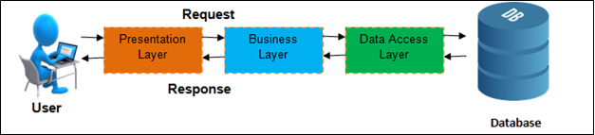

Figure 3:3-tier Structure

## **Work Break Down Structure:-**

Work break down structure is a part of the project which shows the division of the work under different topic of the project. It shows the breakdown of project in manageable form.

Work Breakdown Structure for the project is shown below:

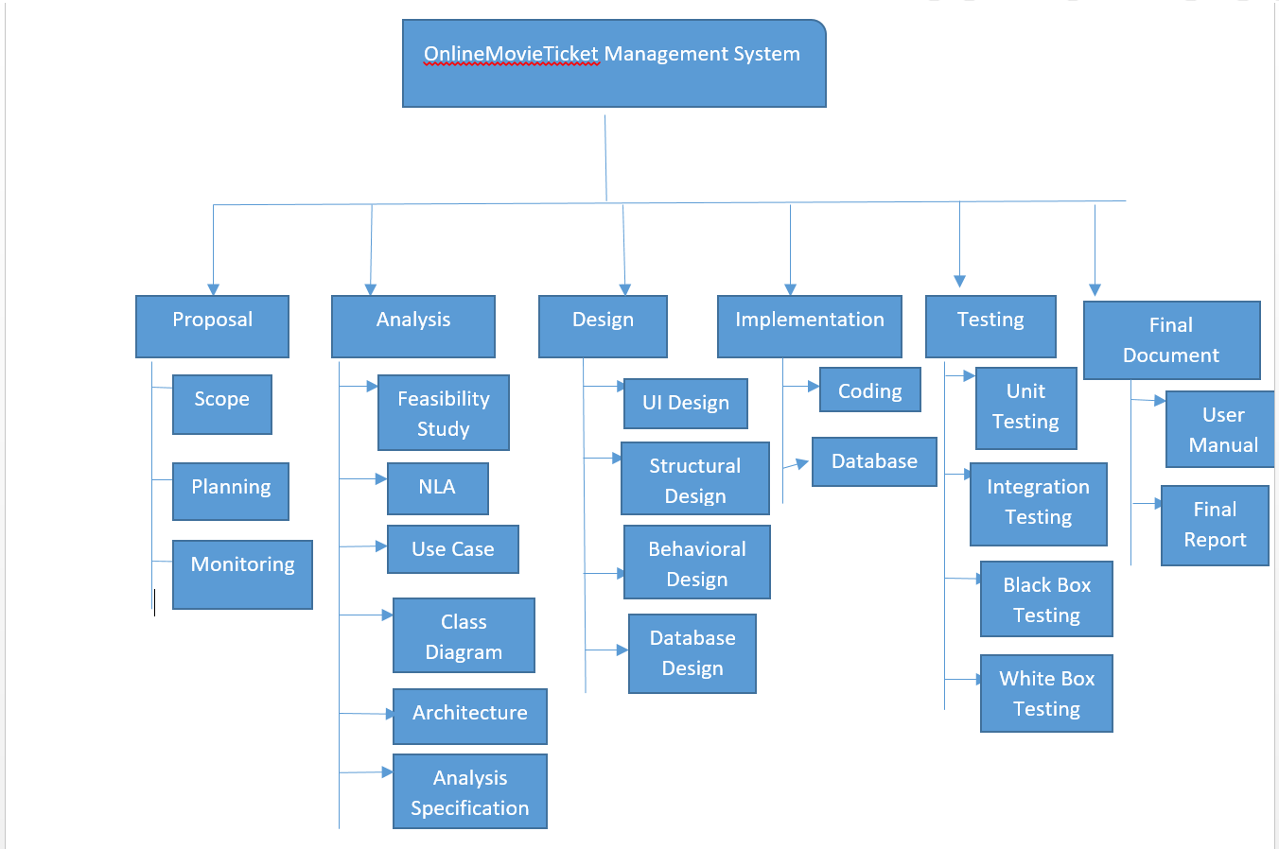

Figure 4: WBS structure

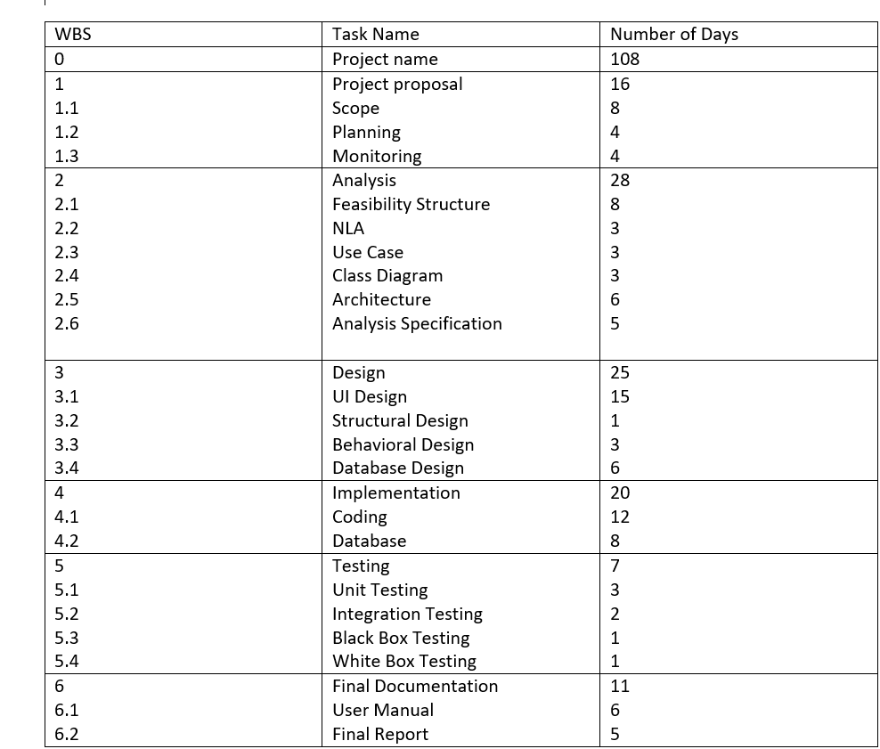

Figure 5: Tabular form of WBS structure

## **Milestone:-**

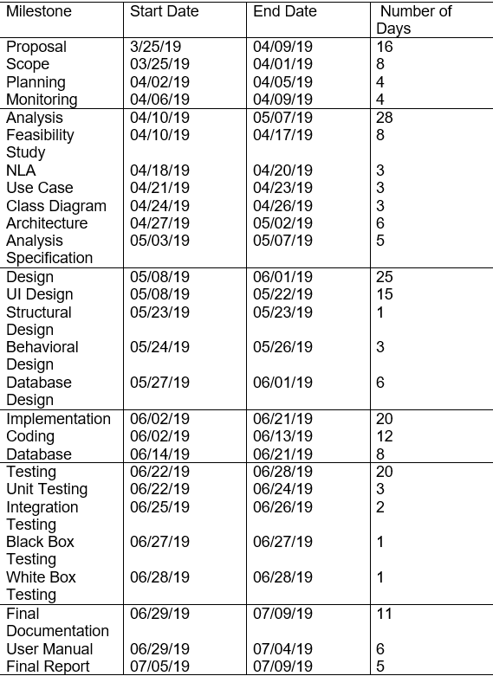

Figure 6 milestone

## **Description of Milestone-:**

* Proposal:-

For the proposal I have estimated 16 days. In 16 days I have estimates 8 days for scope, 4 days for planning and also 4 days for monitoring. I have completed my proposal for the project according to the estimated days.

* Analysis:-

For the analysis segment I have estimated total 28 days. Analysis contains 6 sub parts like feasibility study, NLA, Use Case, Class Diagram, Architecture and Analysis Specification. I have estimated 8 days for feasibility study,

2 days for NLA, 3days for Use Case, 3 days for Class Diagram, 6 days for architecture and also 5 days for analysis specification.

* Design:-

For the design section I have estimated total of 25 days. Here for UI design I have estimated 15 days, I have divided 1 day for structural design, 3 days for behavioral design, 6 days for database design. By this way I have divide 25 days for design.

* Implementation:-

For the implementation I have estimated 20 days. I have divided days for implementation in the following ways-:

I have 12 days for coding part and also 8 days for database part.

* Testing:-

For the testing part I have divided days in the following ways like:-

I have divide 3 days for unit testing, 2 days for integration testing, and also 1 days for black box testing and 1 days for white box testing.

* Final Documentation:-

For the implementation part I have estimated total of 11 days and also I have estimated 6 days for user manual and also for 5 days for final report.

# **Analysis**

Analysis is the process of gather the information of the system from all around to collect all the possible and important information that the system might need. Analysis is also known as gather the information in an organized way to make the system as perfect as demanded. It also means to understand and study the project in a detailed form.

Analysis is one of the most important phase of the waterfall model. By analysis every information regarding the organization is collected which might be very essential.

Analysis should be performed before starting any project so that it may be successful. To complete any project successfully, it is most important to not complicate the analysis and to clearly present results.

For this project, I have choose CATWOE analysis as my project is more concerned about customers, world view, actors, transformation Process, owners and environmental constraints.

Analysis helps in various factors like-:

* Elimination of costs-: by doing a proper analysis, cost can be estimated before performing the task which helps the company.
* Modernizing-: Analysis also helps the staff to follow the modern practice to develop the system as it would be more possible to meet the customer’s requirement.
* Design flaws-: analysis also helps in reducing the flaws of data which might create a great problem in future.
* Customer service-: Analysis helps the staff or the company to provide the great enough services to the customers so that more deal can be expected.

In this project we are going to study about three types of analysis which are mentioned below:-

* Pest analysis -: PEST (political, economic, socio-cultural and technological) Analysis. It helps to understand about the market value whenever it is decreasing or increasing.

This type of analysis provide the proper information about political condition of the country also economical condition and also the technological condition of the company.

* SWOT Analysis-: SWOT Analysis helps to gather the information regarding the strength, weakness, opportunity and threats of the company including project and business competition.

SWOT analysis usually takes feedbacks from the customers and other staff members so that they can improve their weakness and build a great strength

* CATWOE Analysis-: CATWOE is also a type of analysis which stands for Customers Actors Transformation process World view owners Environmental constraints. This type analysis helps to gather every information of the related field.
* Customer-: Mostly, these are a Company’s customers. Customers will obviously be benefitted if any type of positive changes occur in the organization.
* Actors-: They are mostly the staff within an organization. They are also affected with the changes in the company.
* Transformation Process-: Transformation process is denoted as the change made by the process or system according to the project’s scenario. Transformation means that the input (working hours) by the organization is transformed in an output by the organization
* World View-: It is also consider as the most crucial phase of the CATWOE analysis. It can affect not only the staffs or customers but also the external stakeholder and interested company. It is the final result of the analysis.
* Owners-: Owners refers to the entrepreneur or investor of an organization, who wants to make changes and who decides whether a project should start or stop.
* Environmental Constraints-: This refers to the environmental condition of the surrounding which can affect the organization.

## **Feasibility Study**

Feasibility study is a type of type of analysis that considers all the relevant factor of the project. It aims to develop the organization by uncovering the strengths, weakness opportunities and also the threats of the organization

There are the types of feasibility study which are mentioned below:-

* Economic feasibility-: Economic feasibility mostly considers about the cost benefit of the organization. It also helps the organization in maintaining the cost used in the project.
* Technical feasibility-: Technical feasibility is most important factors to consider about the monetary factors of the organization. Technical feasibility also helps to plan for the long term and also trouble shooting. it helps to determine facility needs, raw materials which are most important for the organization.
* Schedule feasibility-: Schedule feasibility helps the organization to maintain the work till the end date. It helps tin scheduling the project in a proper time. It helps in time management which is much needed in any type of organization. Proper scheduling of the project make the project more realistic and practical.
* Operational feasibility-: Operational feasibility helps the staff with the proble created while developing the project. It also helps in the identification of requirement phase.
* Legal feasibility-: legal feasibility helps to deal with the legal function or legal activity happening around the surrounding. It helps the staff works effectively without breaking any types of legal rule.

## **Requirement Analysis**

Requirement analysis is one of the type of the analysis which is critical to the success or failure of a system.

Requirement analysis are performed for the following reasons

* It helps to reduce defect in the delivered products
* It helps to deliver the product quickly.
* It helps to lower cost of development
* It helps to reduce miss communication problem.
* Customers would be very satisfied from the organization.

We can gather information from different analysis process for the organization. For this project I have used all of the following requirement gathering process. I have gathered lots of information from these techniques. Some of the requirement gathering process are shown below:

1. Interview
2. Observation
3. Prototyping
4. Focus group
5. Interface analysis

For this project we are going to specify following types of requirements:

* Functional requirements-: Functional requirement defines a function of a [system](https://en.wikipedia.org/wiki/System) , where a function is explained the behavior between outputs and inputs. Functional requirements includes calculations, technical details, and other specific functionality which describes what a system is supposed to accomplish. Functional requirement includes input, output and process.

|  |  |
| --- | --- |
| Functional requirement Id | Title |
| F1 | Registration |
| F2 | Login |
| F3 | Select movie |
| F4 | Book tickets |
| F5 | Select time, date |
| F6 | Check payment process |
| F7 | Add, Update and modify customer details |

* Non-Functional requirements-: A non-functional requirement (NFR) is a [requirement](https://en.wikipedia.org/wiki/Requirement) which identifies criteria which can be used to judge the operation of a system, rather than specific behaviors. NFR are compared with [functional requirements](https://en.wikipedia.org/wiki/Functional_requirement) which defines specific behavior or functions.
* Performance-: Performance of the project should be good enough to make the customer happy and satisfied. Customers satisfaction is most necessary in developing any project.
* Reusability-: Reusability defines as the use of the components or factor repeatedly to reduce errors and to complete the project in short time. Reusability is a frequent activity happens in the development of the project.
* Usability-: For every project to take the higher position in the market, project should be with great interface so that every user can understand how to use the project. Also easy user interface helps to increase more number of customer.
* Security-: Security is a most important requirement in any project. Many project are suffering failure due to the lack security. Project should be developed with security measure so that user should not face any type of problem.

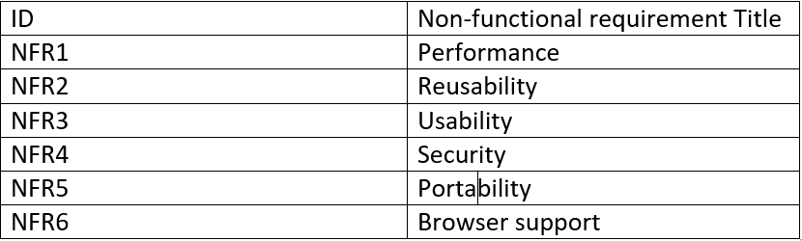

## **Prioritization**

Prioritization is very important while developing the project as it helps to manage the time and effort. Project’s functions are priotized according to the customer choice. Prioritization helps to save time and effort of the staffs. More priotized task are given more importance than less priotized task.

Without prioritization, time management would be very difficult and staff members should focus on each and every task. Task are priotized according to “must have”, “could have”, “should have” and “won’t have” The importance of the prioritization are mentioned below:-

* Prioritization helps us to manage the requirement and resources.
* Prioritization also helps manage the unknown unknowns.
* Prioritization helps to improve communication as the guesswork are taking out of the project.
* Prioritization helps people tend to rethink their requirements.
* Prioritization id helpful when releasing software in phrases.

We have used the MoSCoW prioritization, is also a popular prioritization technique for requirement management. The MoSCoW stands for 4 different categories of initiatives: must-haves, should-haves, could-haves, and will not have at this time.

Different categories contains different works

* Must have (M)-: This category is considered as most important category where very important task are kept. Task which should be performed giving the highest priority are mention in this category.
* Should have(S)-: Should-have prioritization have the function which are less important than the “must have” but very important than the other priority. Functions categorized in this prioritization should be completed before delivery of the project.
* Could have(C)-: Could have prioritization is also one of the important category which includes the functions which are less important than must-have and should have but also important than won’t have. Functions on this category is not compulsory but would be best if included.
* Won’t have (W)-: Won’t have prioritization includes the functions which should not be included in the project/system. This type of category are less prioritized than the other function.

For this project I have used MoSCoW prioritization mentioned in the table below:

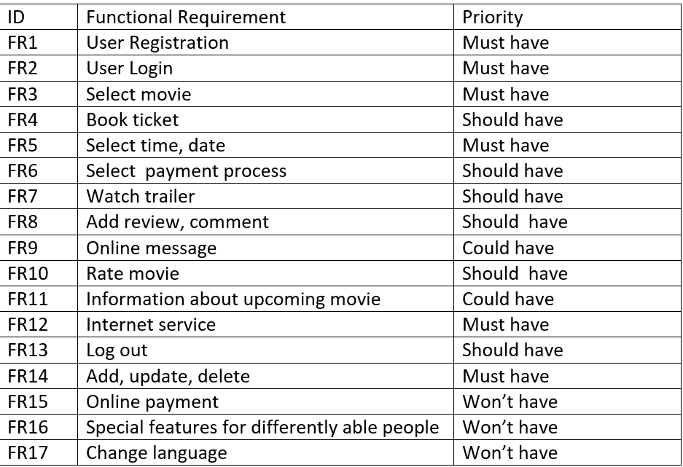

## **Software requirement specification (SRS)**

A software requirement specification (SRS) is a description of a software system which are to be developed with its functional and non-functional requirements. The SRS is developed based on the agreement between customer and contractors.

Software requirement--:

Programming language: PHP language with laravel framework

Database: PhpMyAdmin

UI Design: HTML, JQUERY, CSS, PHP

Web browser: Mozilla, Google Chrome, Opera

Software used: XAMPP Server

* Hardware Requirement--:

Memory: 4GB RAM

Storage: 1GB

OS: Windows 10 64Bits

## **Use-Case**

Use-Case diagram shows the functions of the project in an according order. It also shows the functions performed by customers and admin.

I have created Use Case diagram for the project which is shown below:

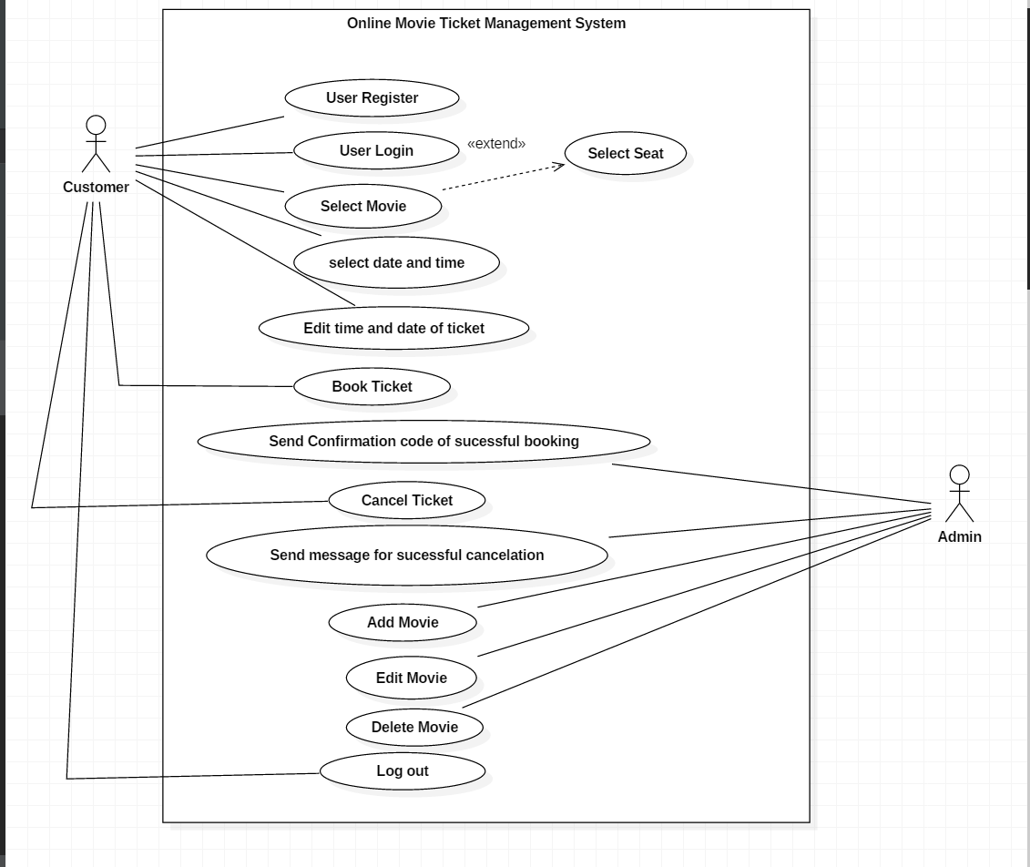

Figure 7 Use- Case Diagram

|  |  |
| --- | --- |
| Use Case | Description |
| User Register | User at first should register their name to get access to login. It may contains some basic information |
| User Login | User should login after registration with valid username and password. |
| Select Movie | User and then can select the required movie for booking. |
| Select Date and Time | User can select Date Time for the movie they want to watch and can enjoy trailer. |
| Edit Time date for ticket | User can also change time, date for the movie if they want to change it. |
| Book Ticket | User can now book the ticket for the required movie. |
| Send confirmation code for successful Booking | User will get the confirmation code if the ticket booking is successfully done. |
| Cancel Ticket | User can cancel their ticket if they want to. User can cancel the ticket 6 hours before the show time |
| Send message for successful cancellation | User will receive the message on their email after cancellation of ticket. |
| Add movie | Admin can add new movies so that the user can visit the theatre to watch movie. |
| Edit Movie | Admin can edit movie if they wanted to. If any kind of changes like release date, time etc should be done, admin will edit movie. |
| Delete Movie | Admin can also delete movie if movie is not running in the theatre or in any other condition. |
| Log Out | User can log Out after they have successfully book their tickets for the movie. |

Natural Language Analysis (NLA)

Natural Language Analysis (NLA) is the process of identifying verbs, adjectives and nouns. For the project I have listed some verbs, nouns and adjectives which can help to make class diagram, use-case and sequence diagram.

List of the noun I have selected for the NLA process are mentioned below:-

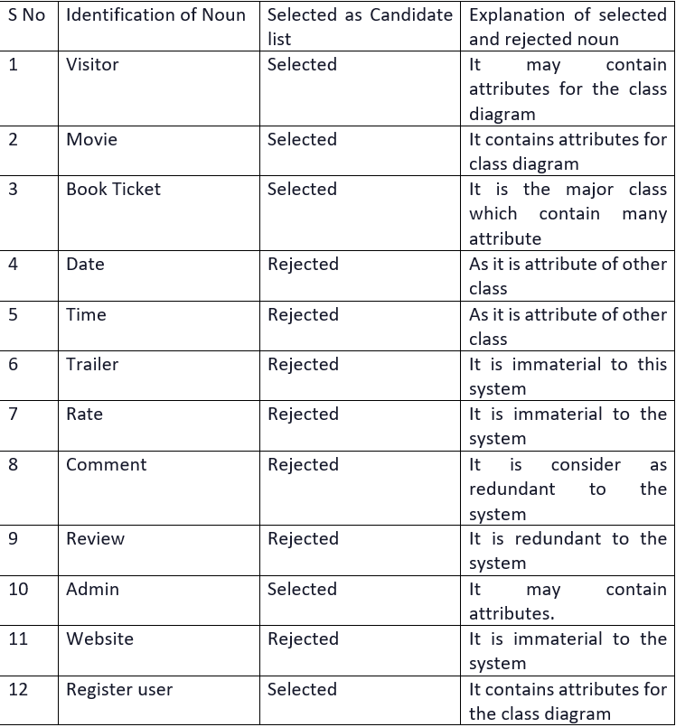

Figure 8 NLA

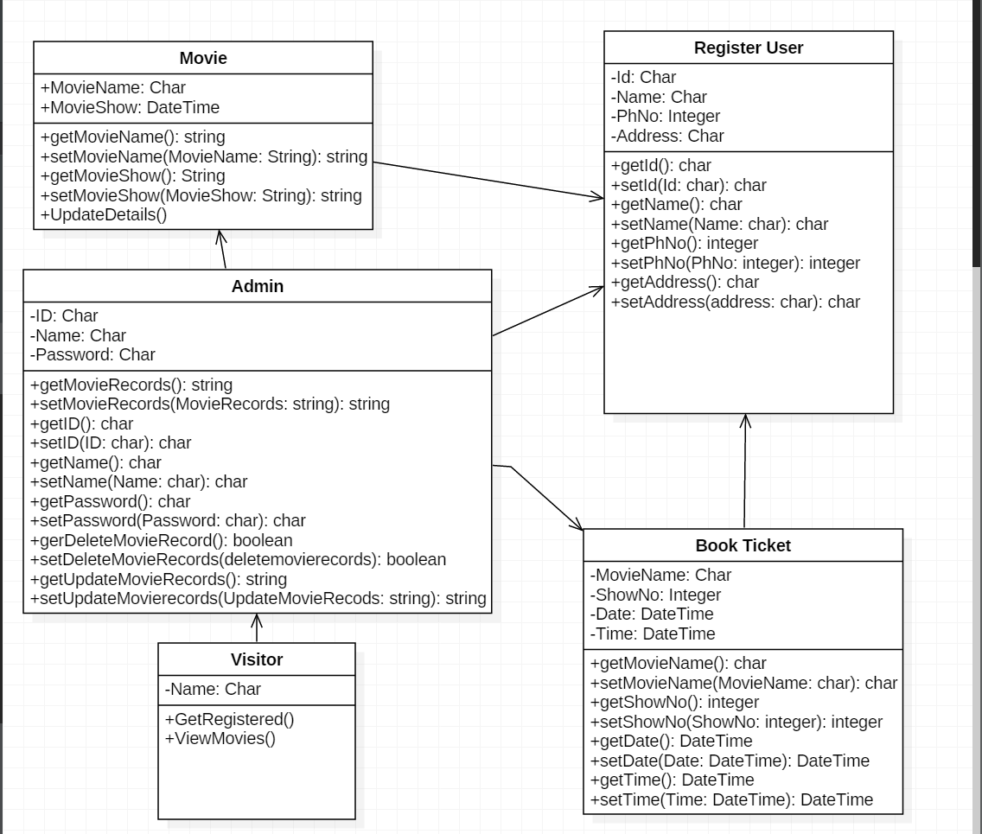

Figure 9 initial class diagram

# **Design**

## **Class Diagram**

Class diagram represents the static view of an application. Class diagram is used in visualization of the project.

The class diagrams is widely used in the modeling of object oriented systems which can be mapped directly with object-oriented languages.

The importance of class diagram is:-

1. It also shows the static view of the diagram.
2. Diagram provides basic notation for other structure diagram.
3. It helps the developers and other members.
4. Class diagram is also used by the business analysts to model systems from business perspectives.

The Notation used in class diagram are-:

Association

Aggregation

Class Diagram used in this process are shown below-:

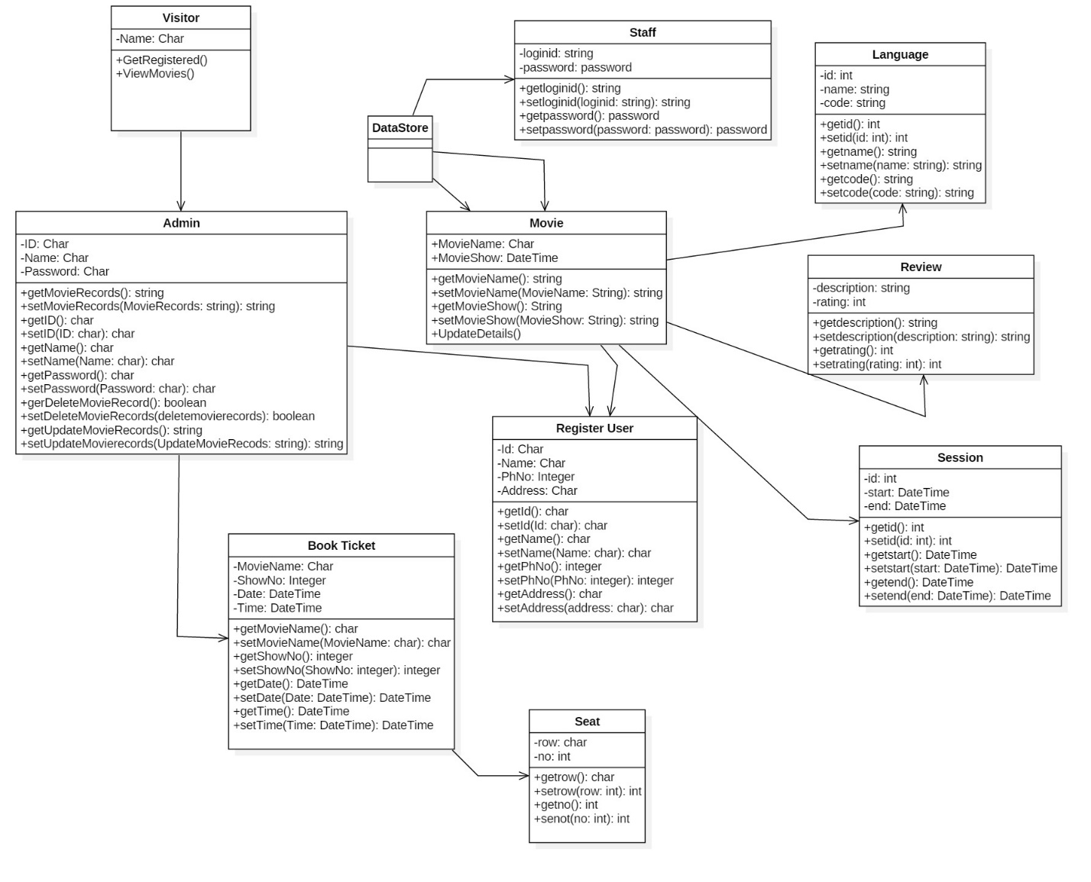

Figure 10 final class diagram

## **Flow Chart**

Flowchart is a type of diagram that shows the workflow or process. This diagram shows the flow chart of the activity happening in the project.

Importance of flowchart in the system are-:

* Communication: Flowcharts helps in development of better communication between the logic of a system to all concerned or involved.
* Effective analysis: With flowchart, problem can be analyzed in more effective way which helps in reducing cost and wastage of time.
* Proper documentation: Flowcharts serve as a good program documentation, which is important for various purposes.
* Efficient Coding: The flowcharts act as a blueprint during the analysis of a system and program development phase.

The Notation used in the flow chart are-:

* An end or beginning
* A step in the flowcharting process
* Directional flow
* Diamond: - decision

Flow Chart for the Project are shown below:

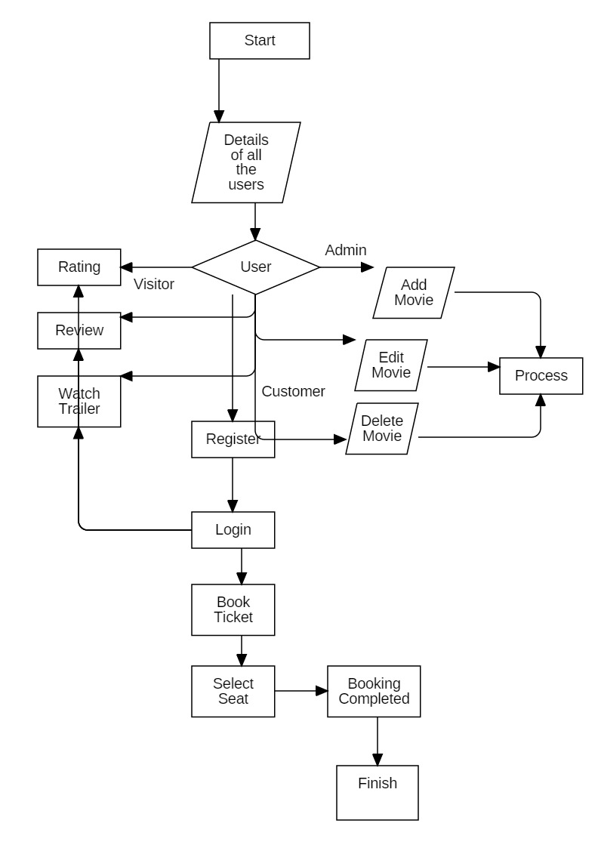

Figure 11 Flow Chart

## **Activity Diagram**

Activity diagram is another important diagram which helps to describe the dynamic aspects of the system. Activity diagram is also defined as a flowchart which represent the flow from one activity to another activity. Importance of Activity Diagram are-:

1. Flow chart helps to depict workflows and is used by the programmers.
2. It is used to understand the flow of programs.
3. Activity diagram is also used to show message flow from one activity to another.

The Notation used in the diagram are shown below:-

1. Activity

1. Action
2. Control flow It shows the sequence of actions.
3. Object flow
4. Initial node
5. Activity Final Node: -
6. Decision node
7. Merge node

1. Fork node
2. Join node
3. Swim lane and Partition

Activity diagram used in this project are shown below:

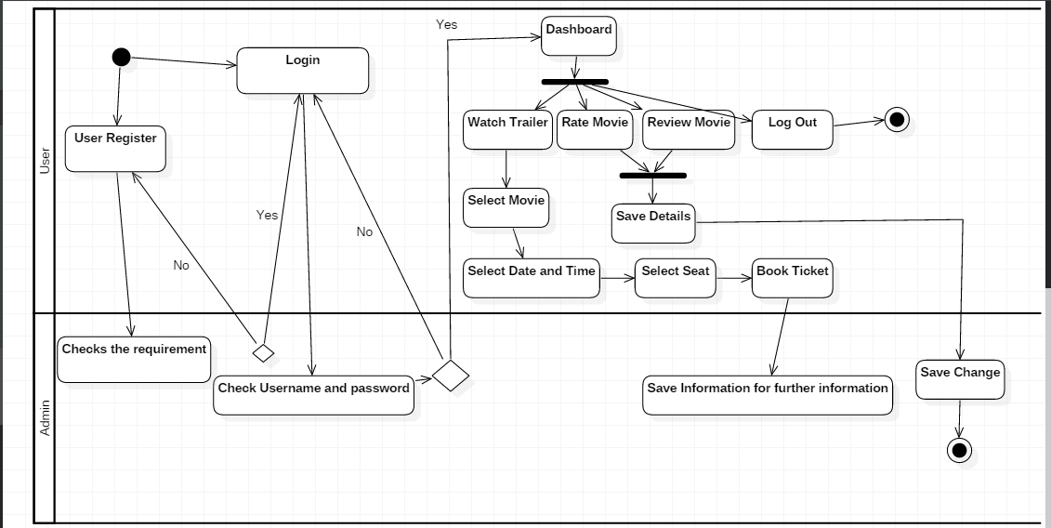

Figure 12 Activity Diagram

## **Sequence Diagram-:**

UML Sequence Diagrams are interaction diagrams that explains how operations are carried out. They shows the interaction between objects in the context of a collaboration.

The reason the sequence diagram is so useful is because: -

1. It explains the interactions logic between the objects in the system in the time order that the interactions take place.
2. Sequence diagram are simple to modify, which allows vertical expansion than the horizontal which is the case for sequence diagram.
3. It is an essential component used in processes related to analysis, design and documentation.

Notation used in this diagram are shown below-:

1. Lifeline: - it represents each instance in an interaction.
2. Activate: - it is used to denote participant activation. Once a participant is activated, its lifeline occurs.
3. Objects: - they are model elements that represent instances of a class or of classes.
4. Classes: - In UML, it shows architecture and features of the designed system.
5. Message: - it is an element that defines a specific kind of communication between instances in an interaction.

Sequence Diagram used in this project are shown below:-

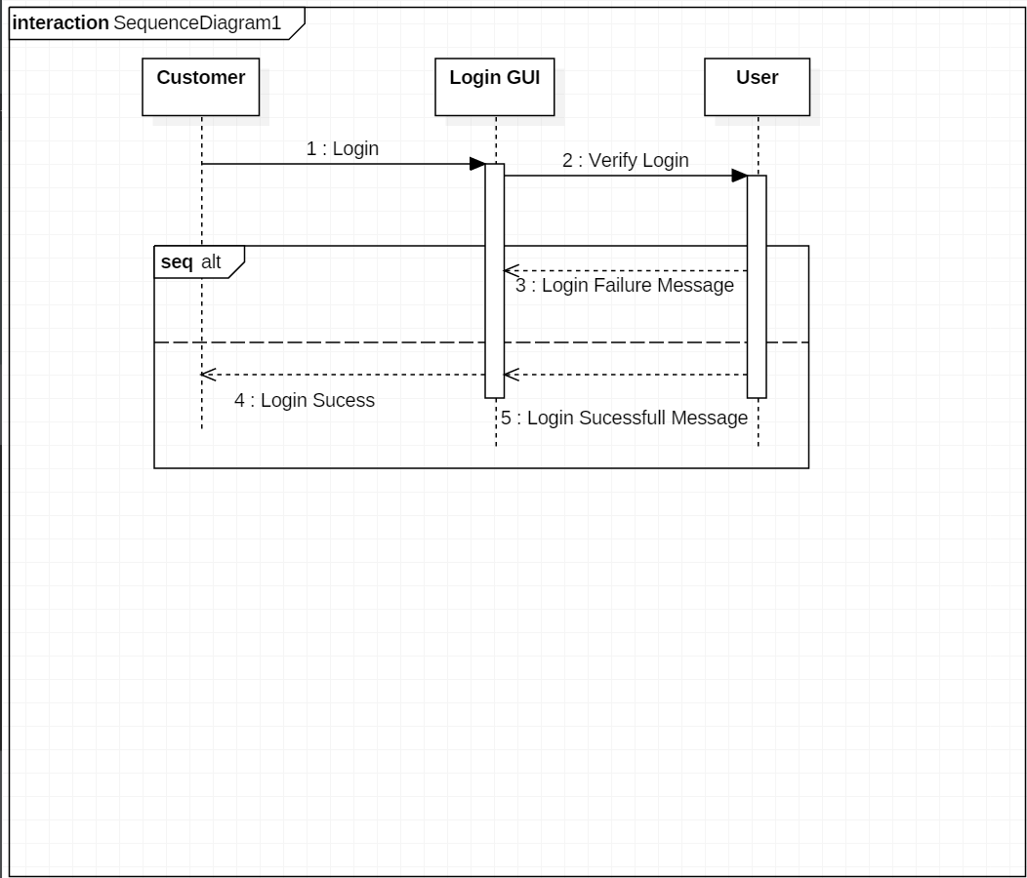

Figure 13 Sequence Diagram for login

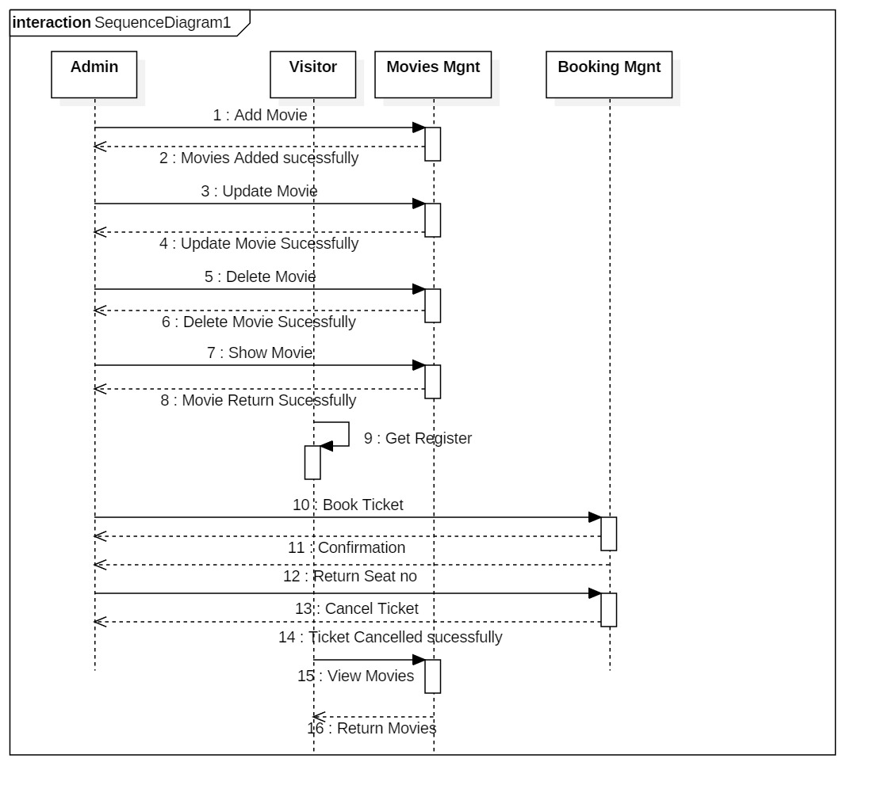

Figure 14 Sequence Diagram for Project

## **Data Base**

1. Data Dictionary -:

A data dictionary is a file or a set of files which contains a metadata of database. The data dictionary contains records about other objects in the database, such as data ownership, data relationships to other objects, and other data.

Data Dictionary for this project are shown below:-

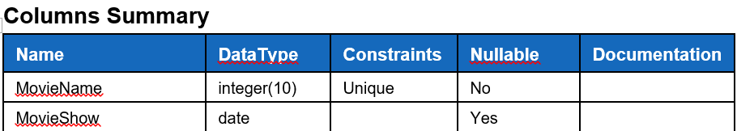

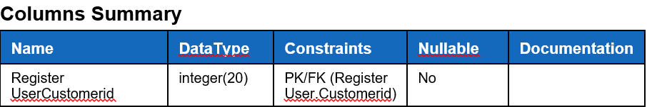

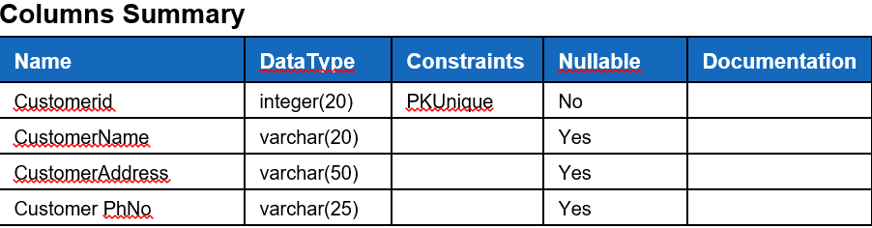

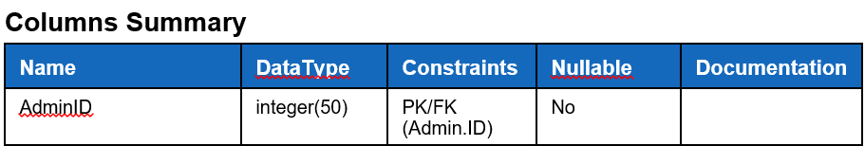

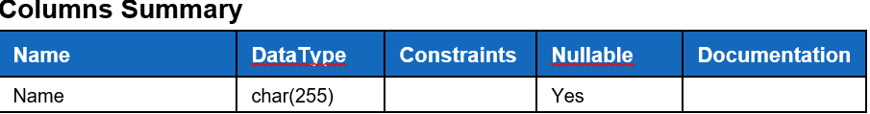

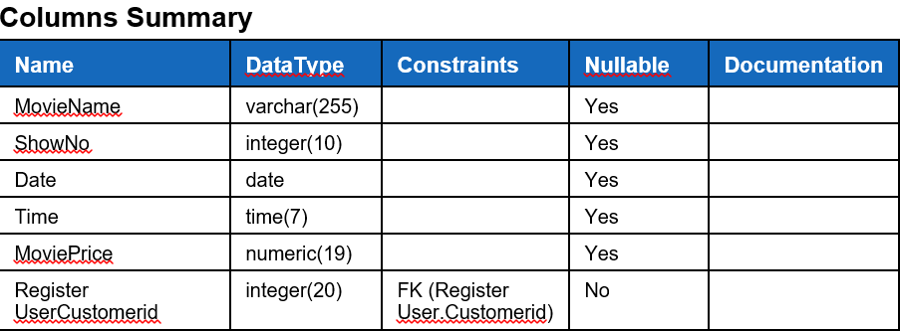

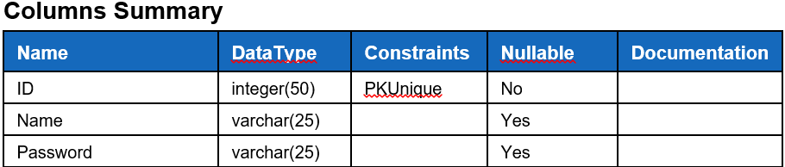

## **ER Diagram**

ER diagram also known as means of communication. It shows the relation between the classes along with attributes of the system. It helps to produce high quality database design used in database creation

ER Diagram for this project are shown below-:

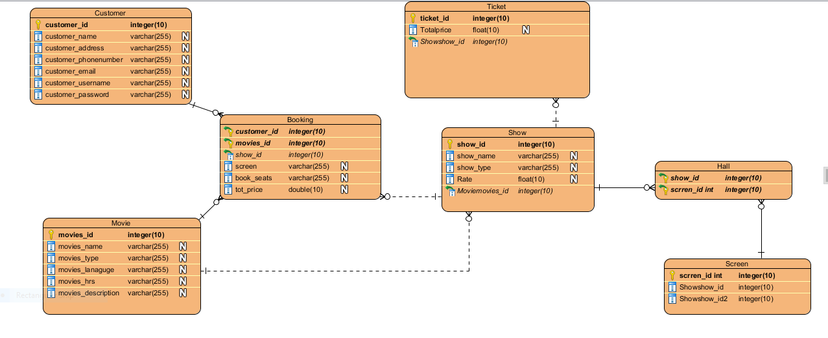

Figure 22 E R Diagram

## **Prototyping-:**

**Digital Prototype**

A prototype is a digital simulation or demo of a product or service that enables you to test assumptions and virtually explore a product before it’s built. Digital prototyping can save you time and money by ensuring that product development is based on data from the outset, rather than untested assumptions.

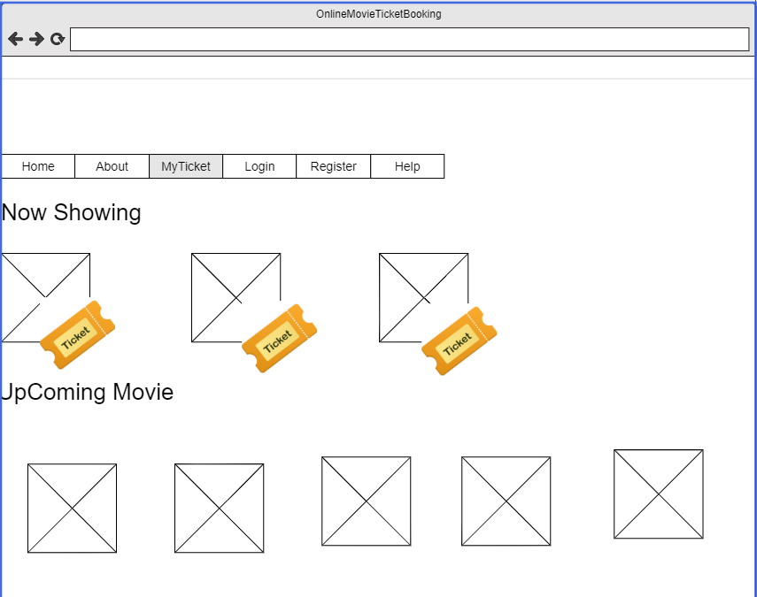

Figure 23: Protype of Home page

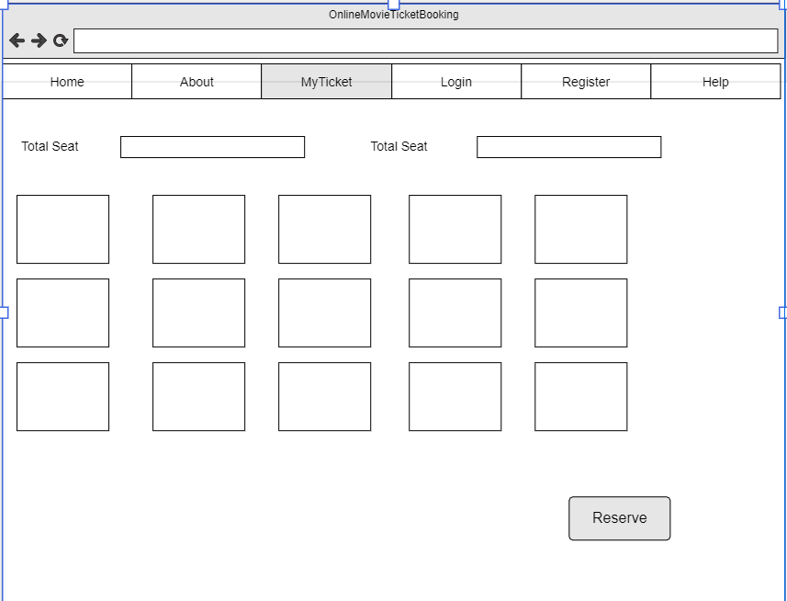

Figure 24 : Protype of Seat Chart

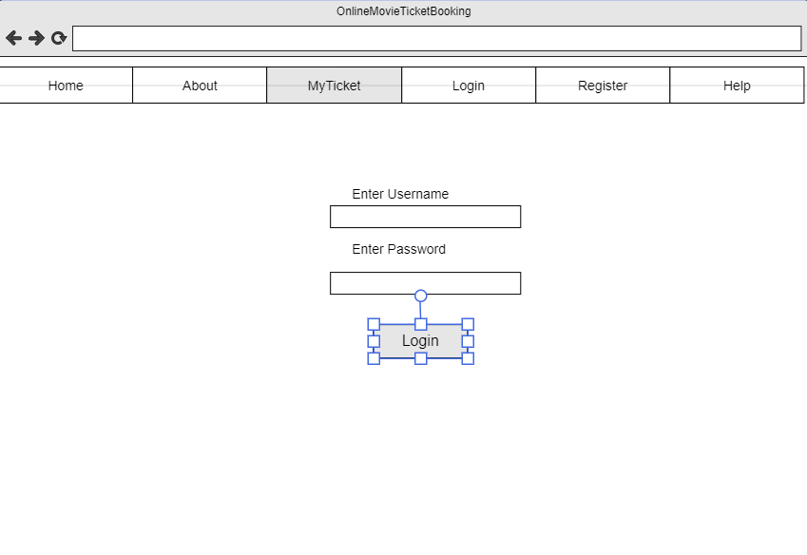

Figure 25 : Protype of Login

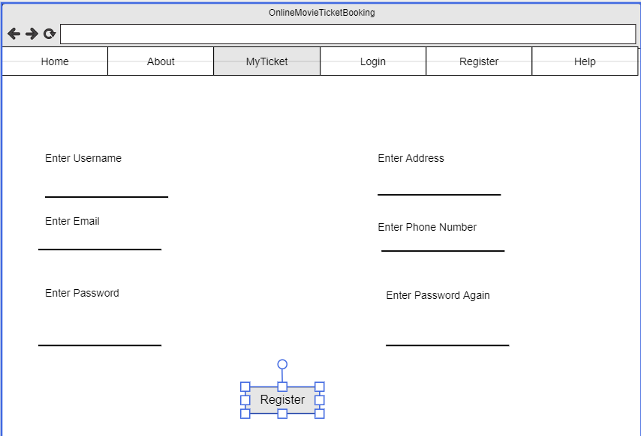

Figure 26: Prototype of Register

## **Architecture-:**

In this project I have used 3 –tier structure. A 3-tier architecture is a type of software architecture which is made up of three “tiers” .They are mostly used in applications as a specific type of client-server system. 3 tier structure used in this project are shown below:-

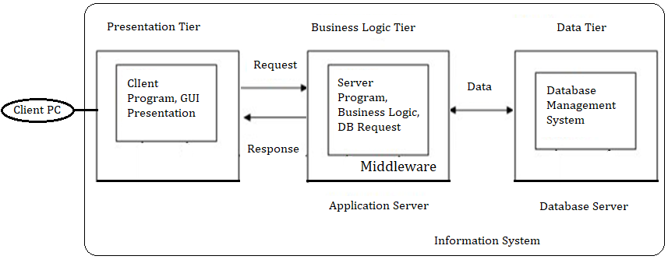

Figure 27 3-tier structure

1. **Presentation Tier-:**

The presentation tier is the graphical one accessible through a web browser or web-based application and which shows content and information useful to an end user. This tier is built on web such as HTML5, JavaScript, Php, CSS, or through other popular web development.

1. **Application Tier-**The application tier drives an application’s core capabilities. It’s often written in Java, .NET, C#, Python, C++, etc.
2. **Data Tier-**The data tier is about the database/storage. Examples are MySQL, Oracle, Microsoft SQL Server etc.

Importance of 3 tier architecture in this project are shown below:-

* It helps in data security in application layer.
* It provides reliability and more independence.
* It provides the object oriented object easily.
* It provides data update queries.

## **Testing**

Testing is one of the phase of the waterfall model. Testing is done after the implementation phase. Testing is one of the important phase of the waterfall model. It must be performed before handling the project to the customer.

Importance of testing for the project are-:

* It helps to save money of the company.
* It provides security to the software.
* It helps to increase the product quality.
* It helps to make customer satisfy from the work of the organization.

For this project I would do two types of testing which are listed below-:

1. Unit testing
2. Black Box Testing
3. Unit testing

UNIT testing is a type of testing where software components and software testing are checked. The purpose of unit testing is to validate that each unit of the software performs as designed.

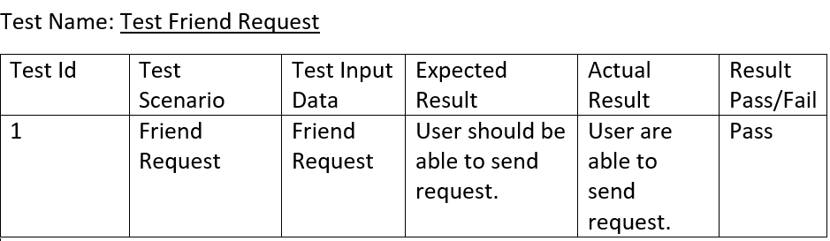

Figure 28 friend request

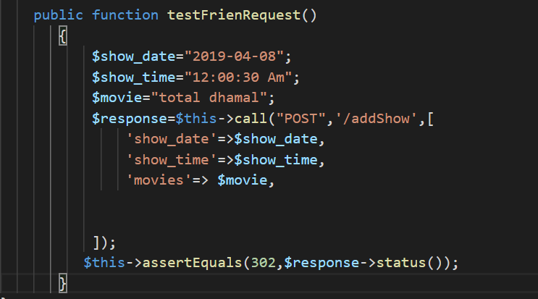

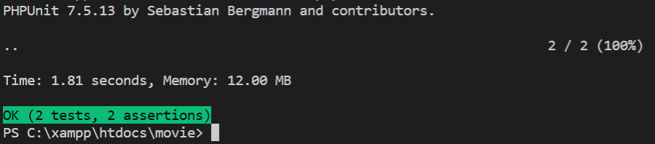

Test Name: Change Password

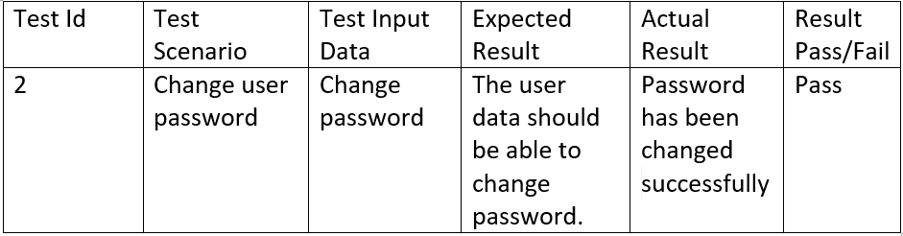

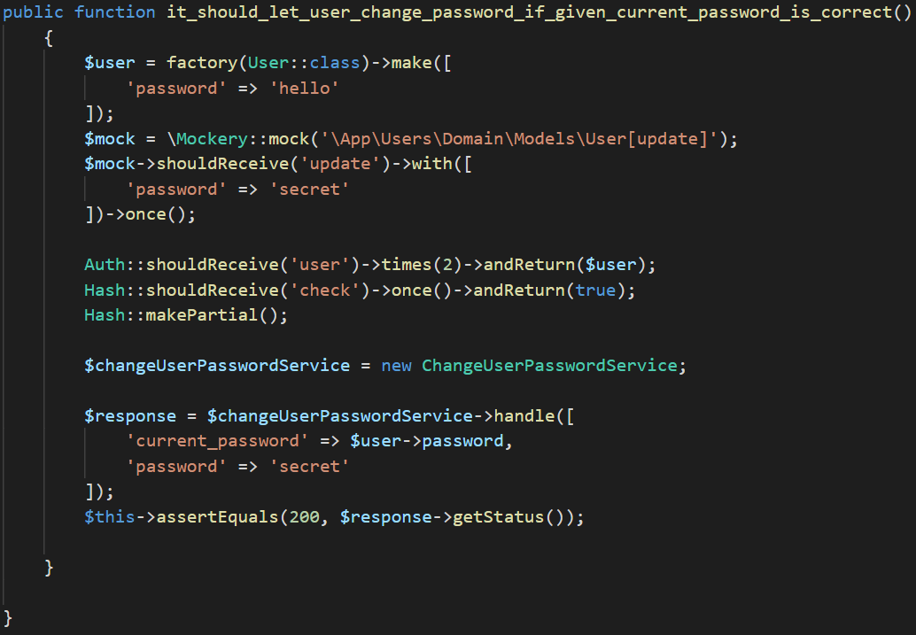

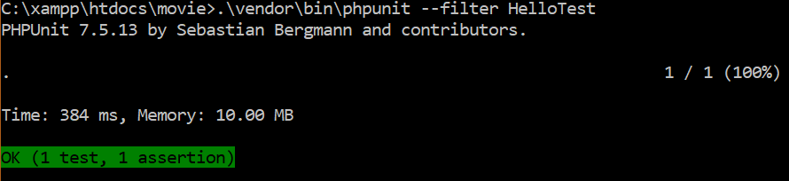

Test Name-: User Login

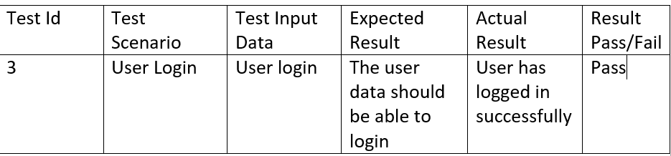

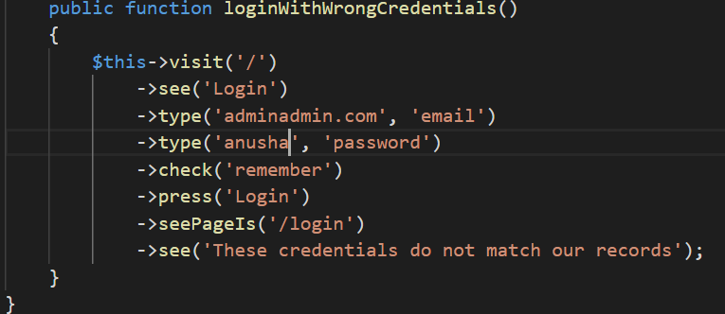

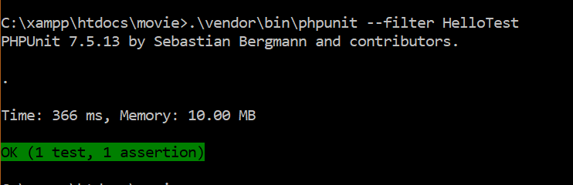

Test Name: Delete User

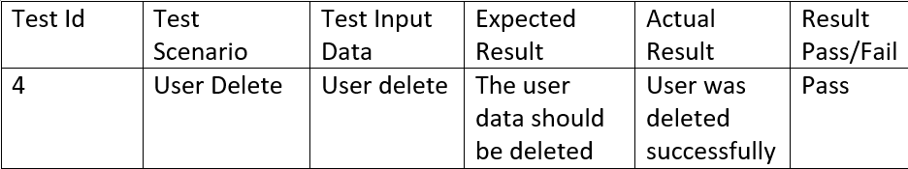

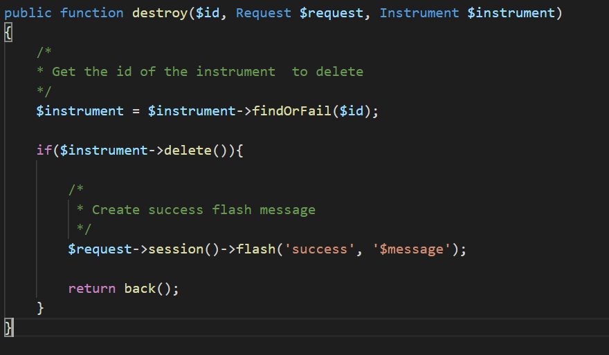

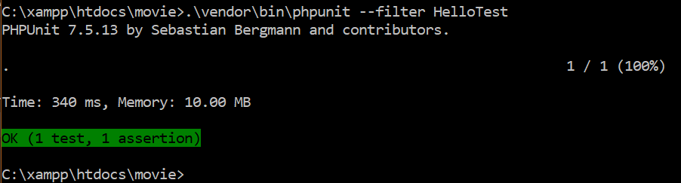

Test Name: Register User

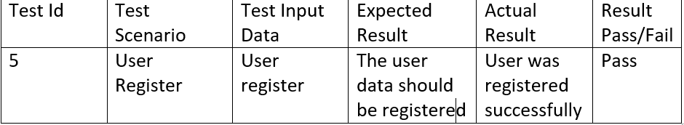

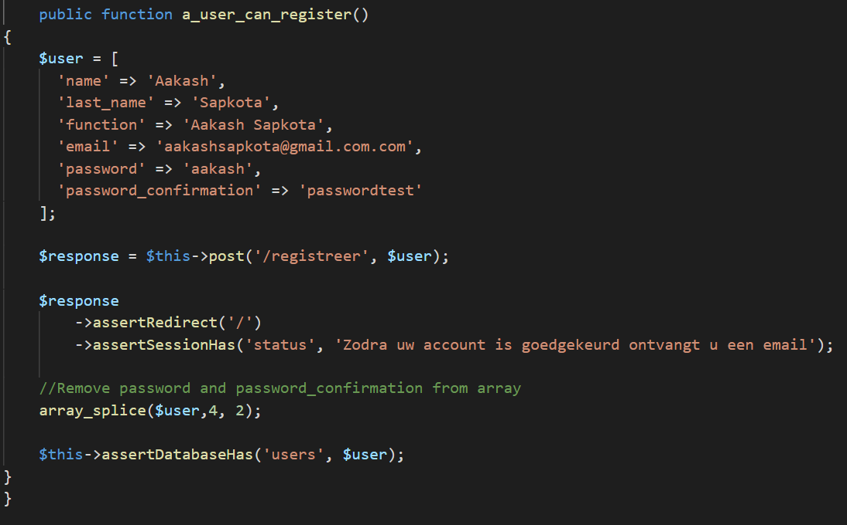

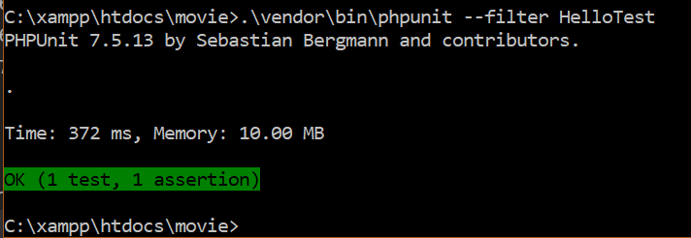

Test Name: Choose Seat

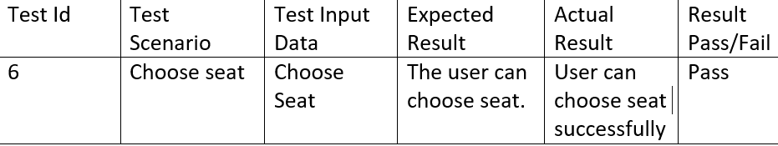

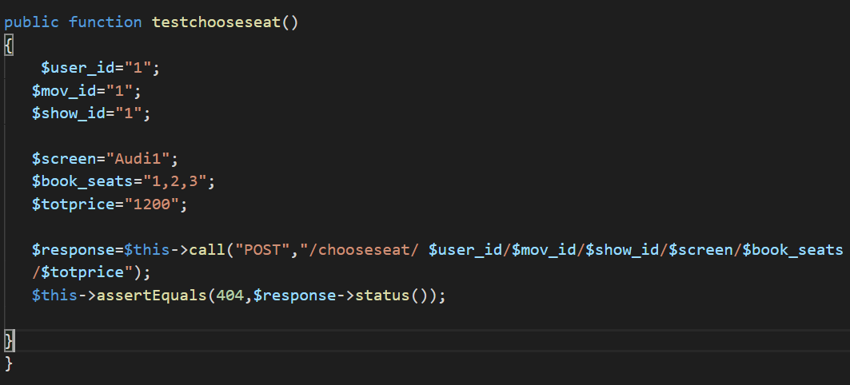

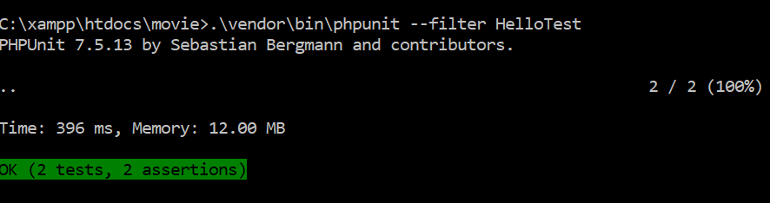

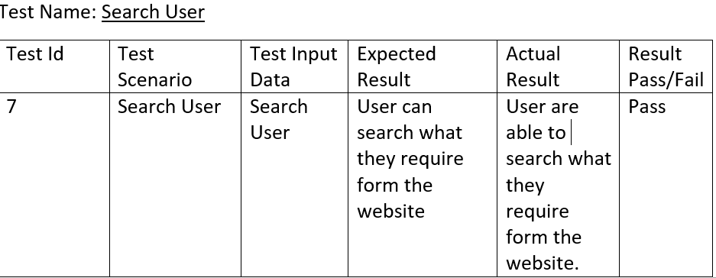

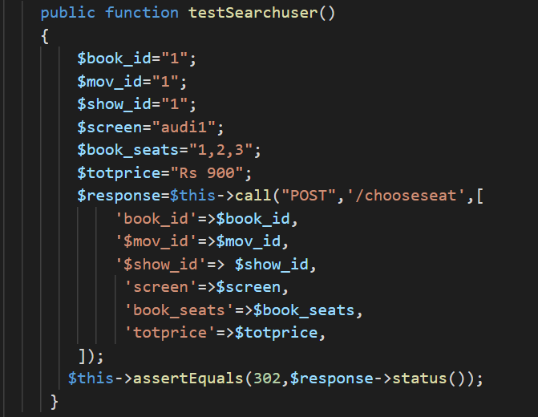

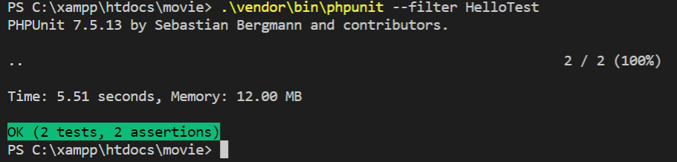

1. Black Box Testing-:

BLACK BOX TESTING is also one of the type of testing which helps to test the outer function of the software. Black Box testing is also known as Behavioral testing also known as Behavioral Testing. Black box testing does not test about the internal functions, coding etc.

For this project I would like to choose black box testing for the following reasons

* It is easier to carry out as there is no requirement to test code.
* It is the simple type of testing focusing on the inputs and output.
* This type of test is completed in short period of time with less complexity.

1. Test Name: Registration Test

Pre-condition: User must get registered into the system

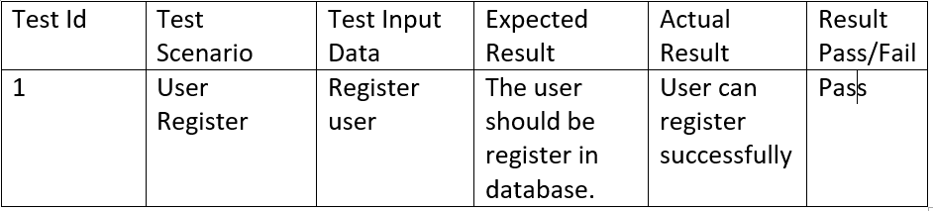

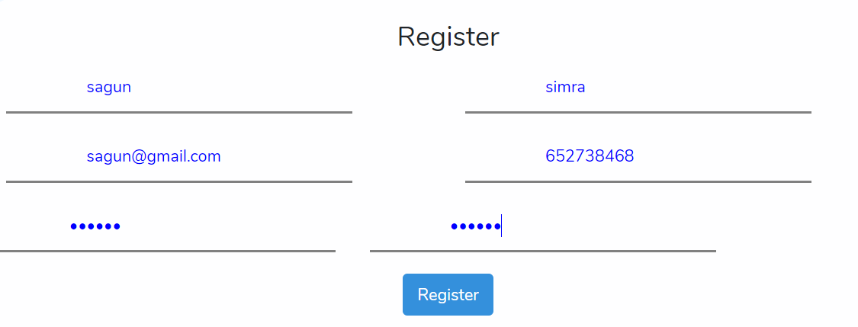



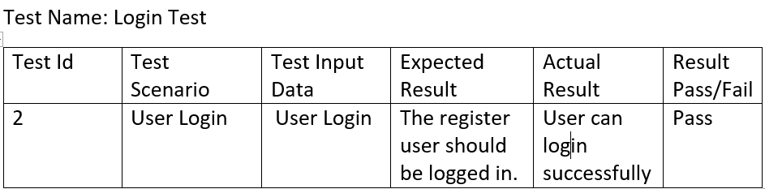

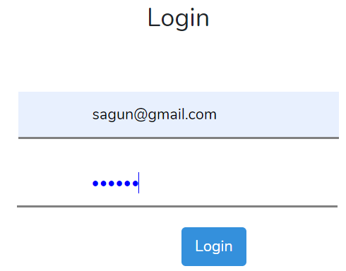

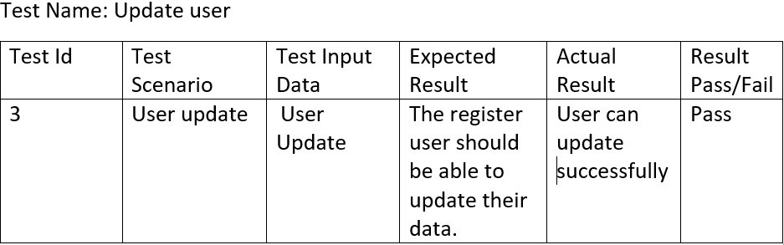

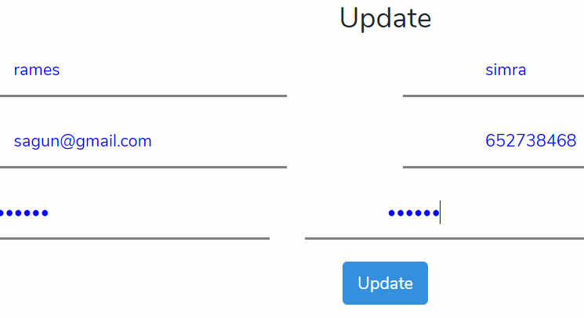





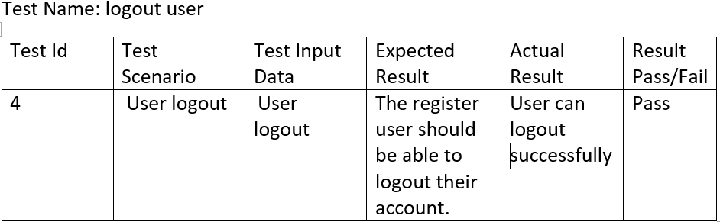

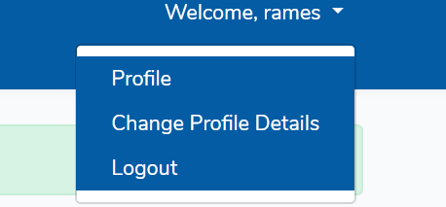

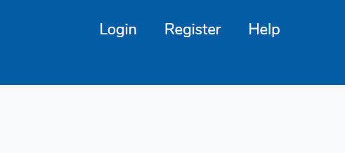

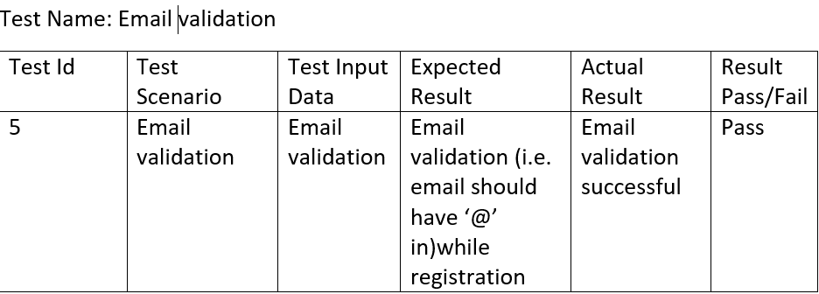

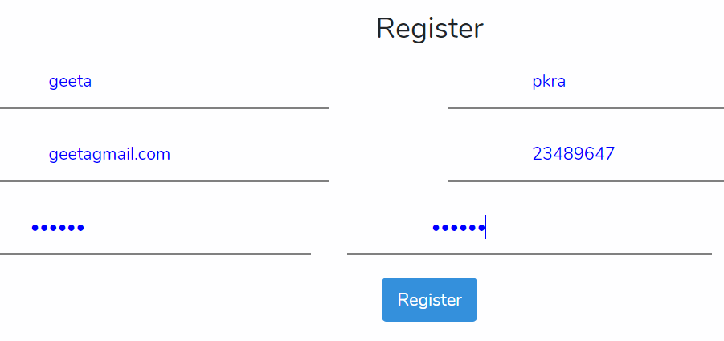

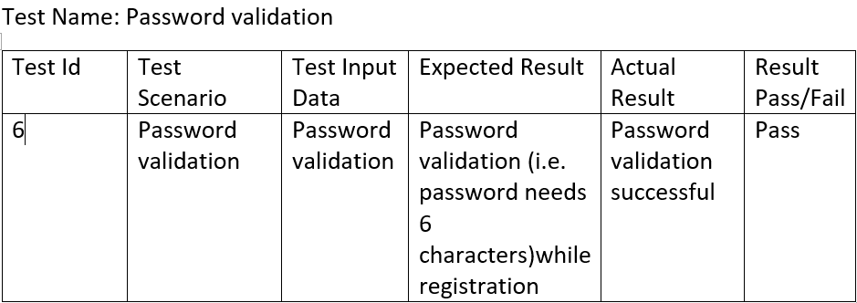

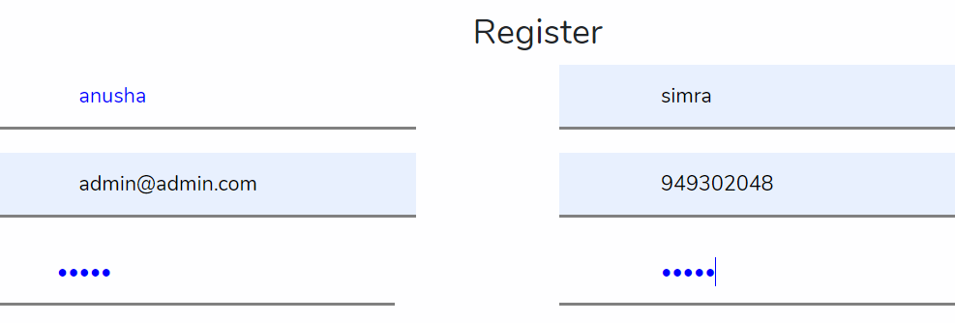

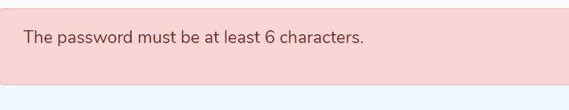

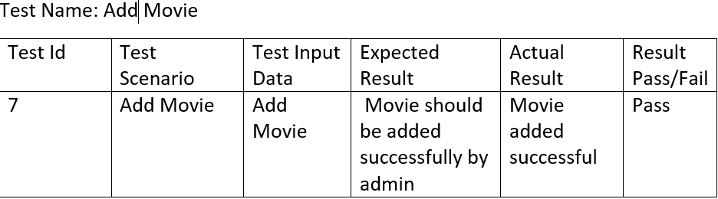

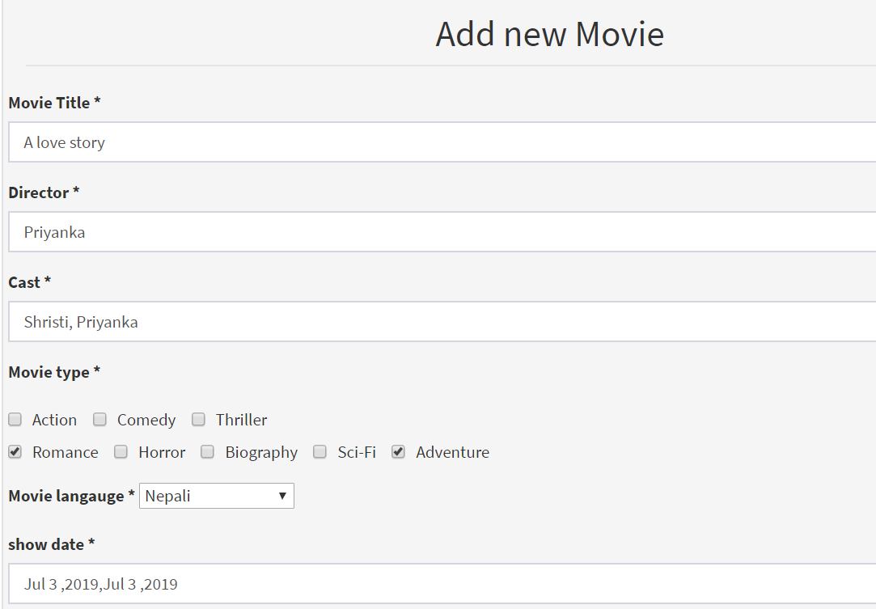





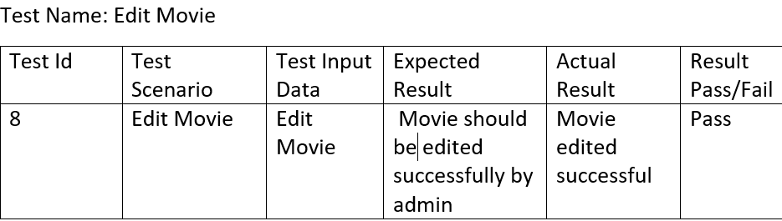

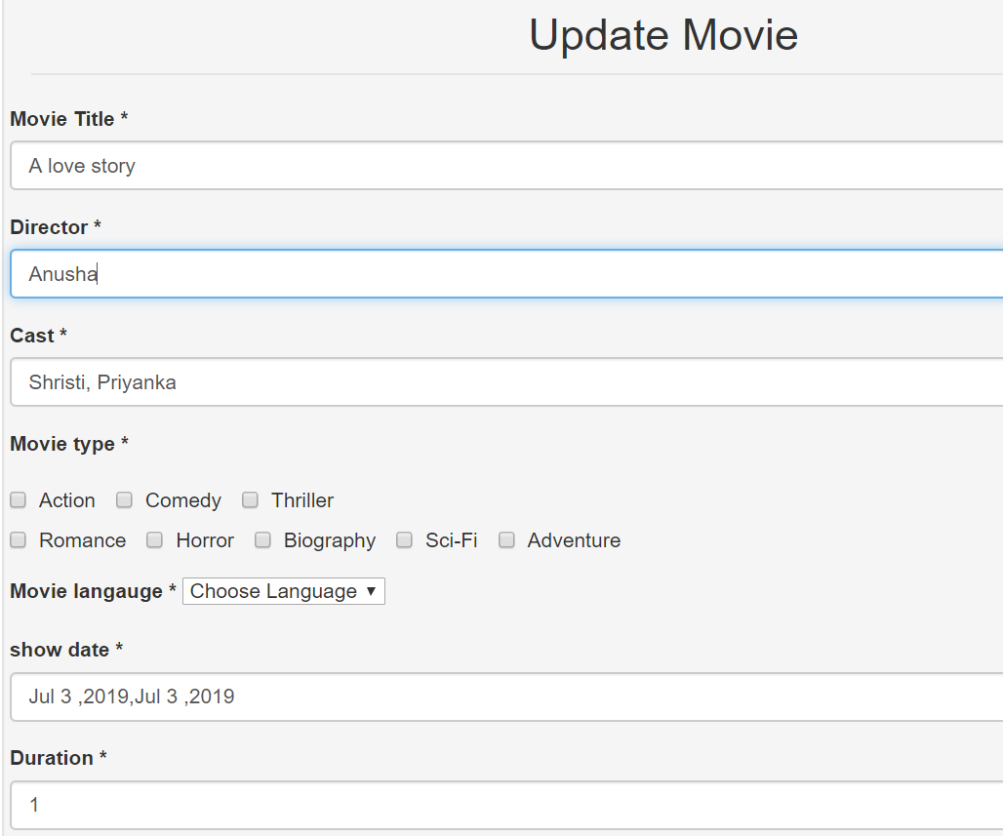

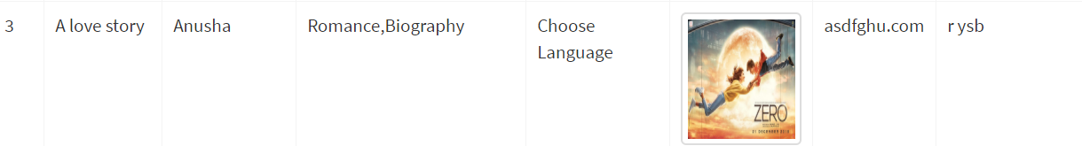

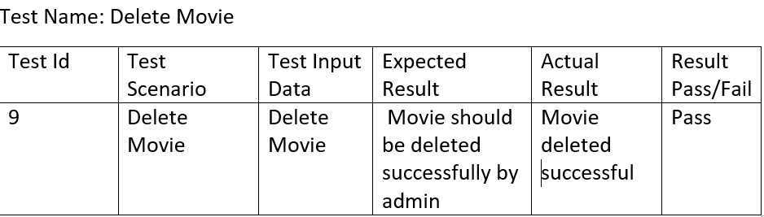

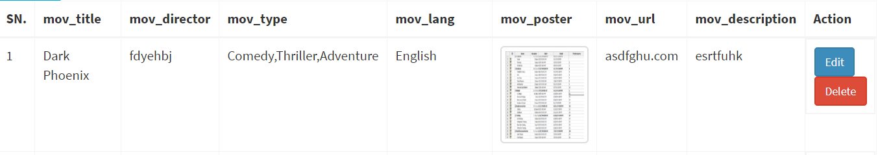



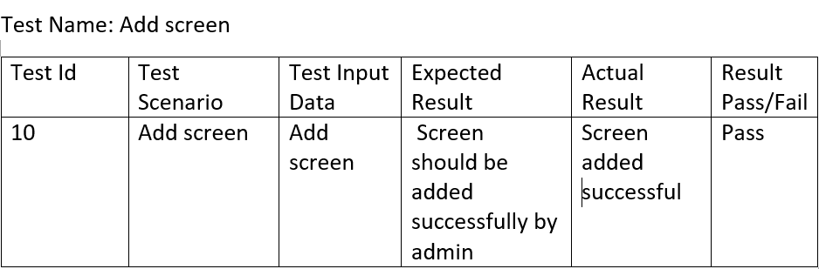

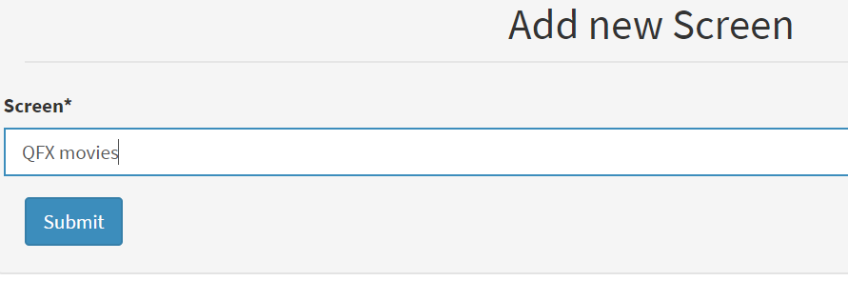





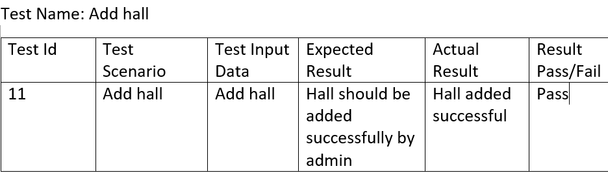

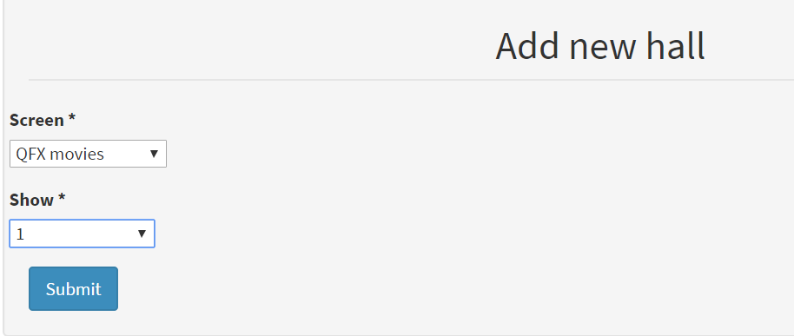





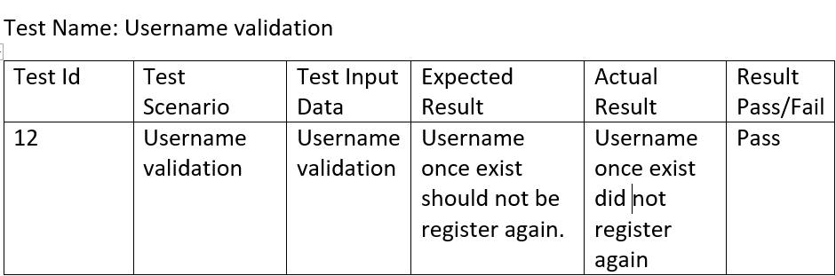

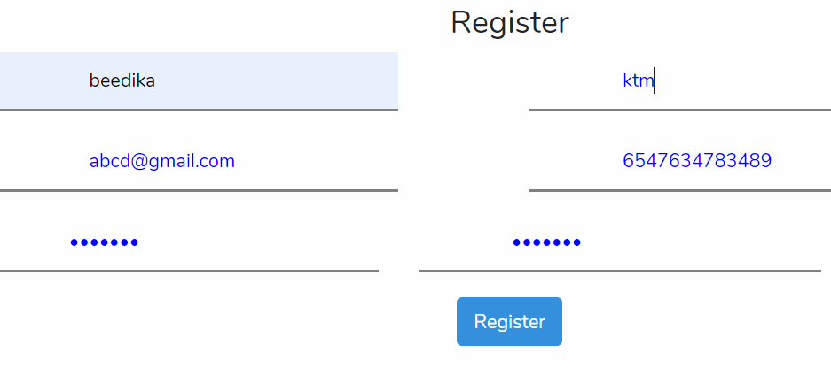

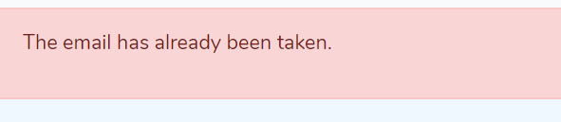



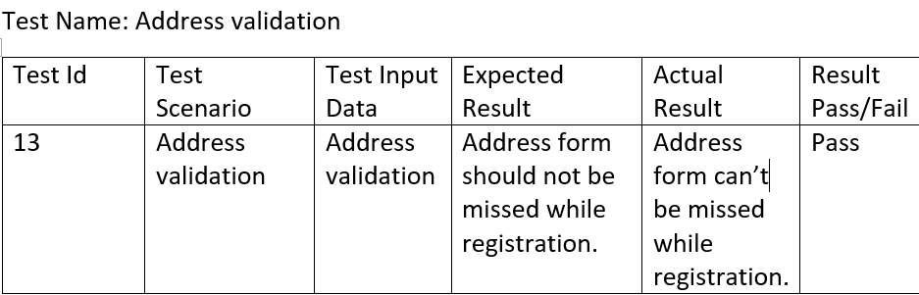

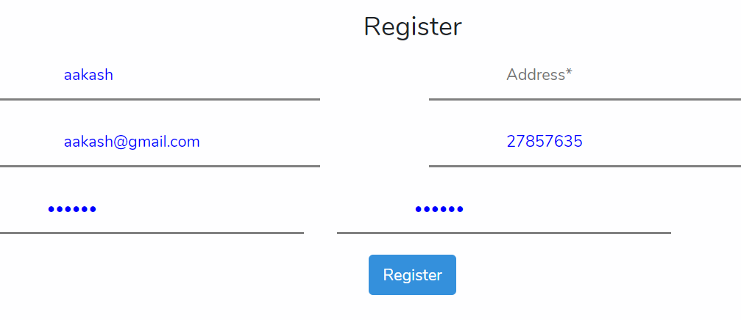

# 

# **RISK Management-:**

Risk management is identification, evaluation and prioritization of risk. It helps of to minimize, monitor, and control the probability or impact of unfortunate events or to maximize the realization of opportunities.

Following are the method to control risk in Project Management are -:

* Avoidance
* Reduction
* Sharing
* Retention



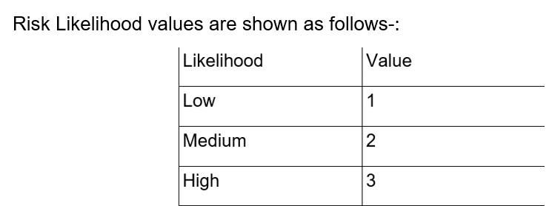

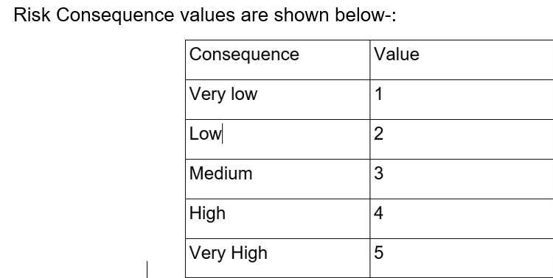

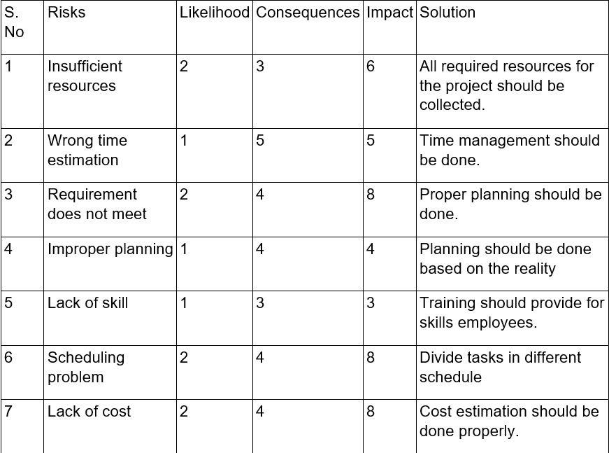

## **Configuration Management**

Configuration management is a type of management which is responsible for handling the systematic changes. Configuration management is also concerned for the creation, maintenance and controlled changes.

Importance of configuration management-:

* It helps to Increase efficiency
* It helps in cost reduction.
* It helps to provide greater agility and solve problem faster.
* It provides the reliability of the system in an enhanced way

Steps of Configuration Management are:-

* At first Identification of configuration management
* Configuration Management Process
* Environment naming
* Execution of configuration management process
* Configuration tracking and metrics reporting

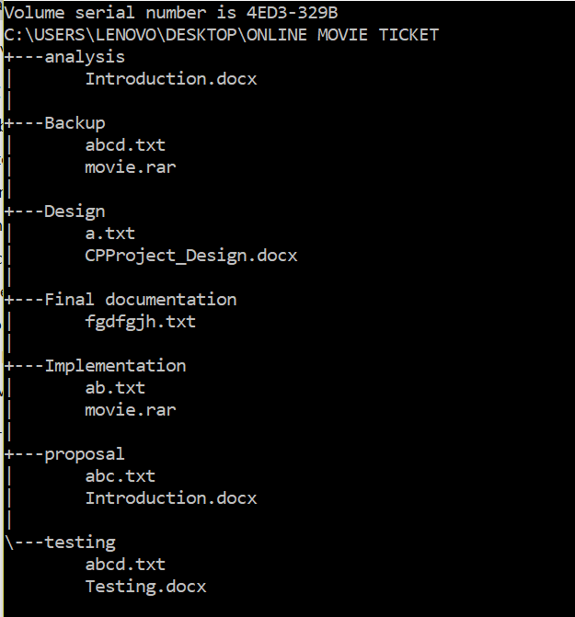

Figure 83 configuration management

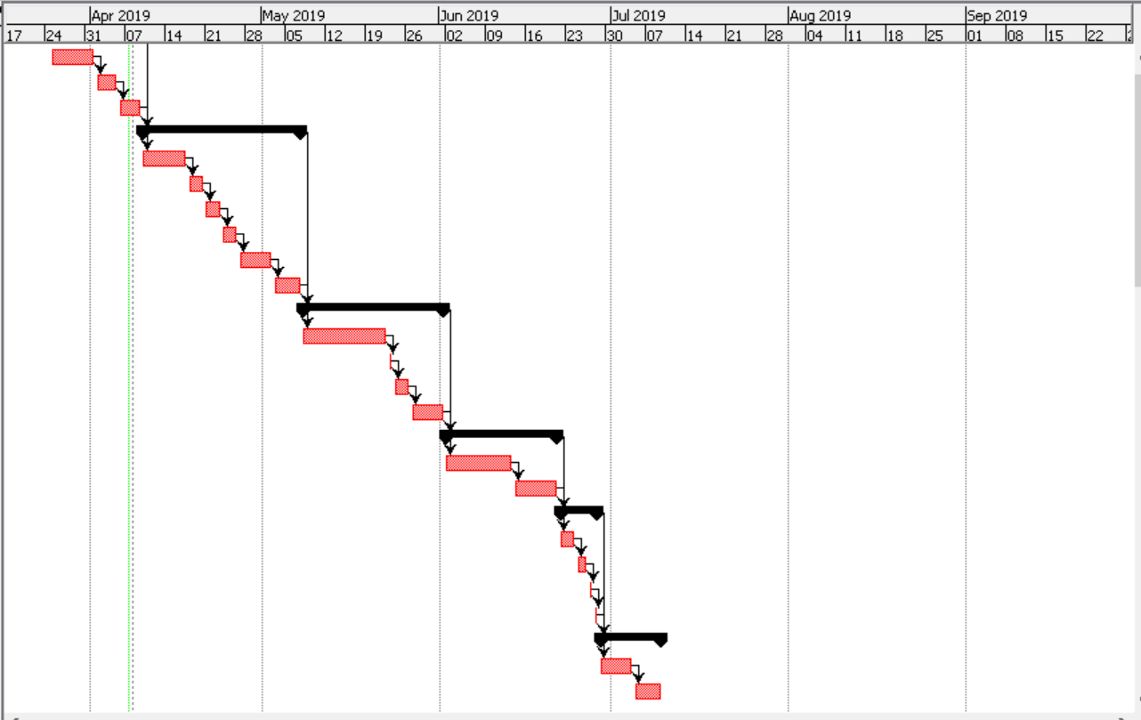

Figure 84: GANTT chart

## **Project Issue**

The issue which were created during project development. It is also the one which provide negative consequences on the project. Different types of issues can be created during project development. Some may have minor affect whereas some may have major affect which might also change the project design. Project issue is created in any type of project.

Some of the project issues face by me during the development of the project are listed below-:

* Improper planning
* Lack of skill
* Scheduling problem
* Wrong time estimation
* Requirement does not meet expectation.

To overcome these problem I have taken help from my module leader, my classmates and also my senior. After that I managed my time again according to the task of the project. I utilized my waste time and focus on the project. After facing all the problem I successfully made the project with the function I have mentioned in the proposal.

## **Limitation**

I have created mostly every function I have mentioned in the proposal though there are some function which I cannot make are listed in this limitation.

For my project there are some limitations which are-:

* User cannot make the payment through online.
* Admin cannot delete the movie due to some reasons.
* User cannot cancel their booking

## **Future Work**

Though some of the task are kept for the future. The list of the task I have kept for the future are mentioned below-:

* Online payment.
* Booking cancel.
* Delete movie by admin.
* Real based seat selection.
* To rate and review for the movie

# **Conclusion**

In this project I have use PHP language with laravel framework. I have created Online Movie Ticket Booking Management System. I have completed my project. The aim of the project is to provide digital facilities to the customer and also to introduce technology to the user. The aim of the project is to help the customers to book their ticket through online so that they can save their time and select their favorite seat.

I have use PhpMyAdmin as the database also this project helps the customer to watch the trailer and get the detailed information about the movie. I have completed this project with the help of the module leader, friends and my seniors. I have faced lots of problem during the development by solving all those I have completed the project. Thus my proposal for the project is completed by this way.

# **References-:**

<https://www.izenda.com/5-benefits-3-tier-architecture/>

<https://en.wikipedia.org/wiki/Systems_architecture>

<https://www.interserver.net/tips/kb/mvc-advantages-disadvantages-mvc/>

<https://www.tutorialspoint.com/sdlc/sdlc_waterfall_model.htm>

# **Appendix**

Laravel MVC design pattern

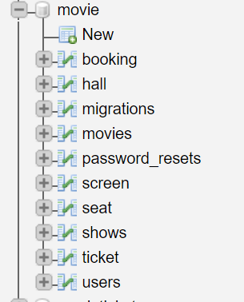

Figure 85 database

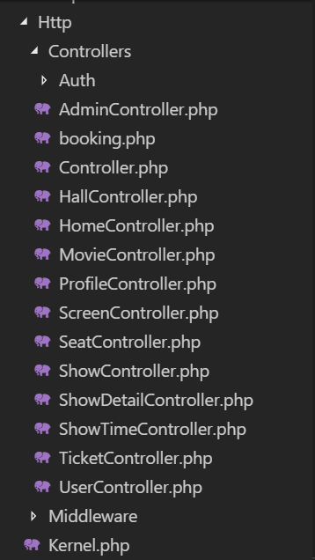

Figure 86 Controller

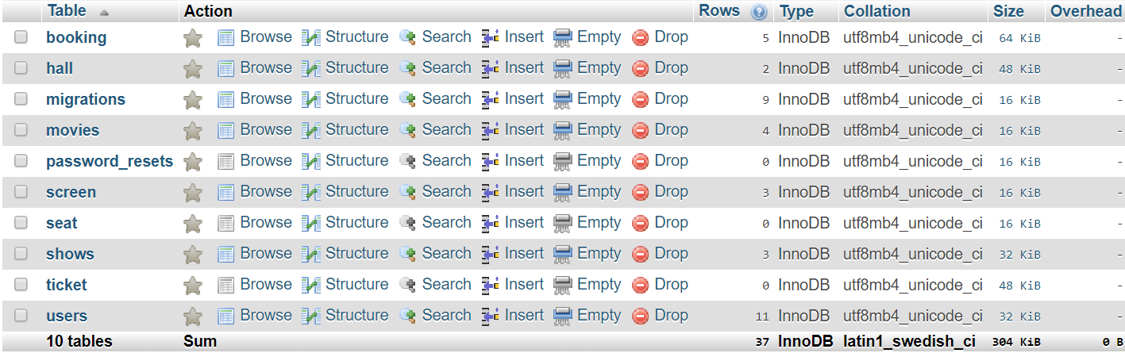

Figure 87 database

**Model**

1. User Model

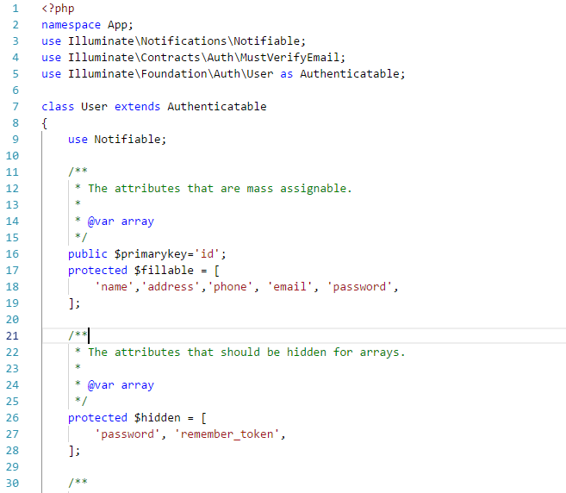

Fig:user model

1. Movie Model

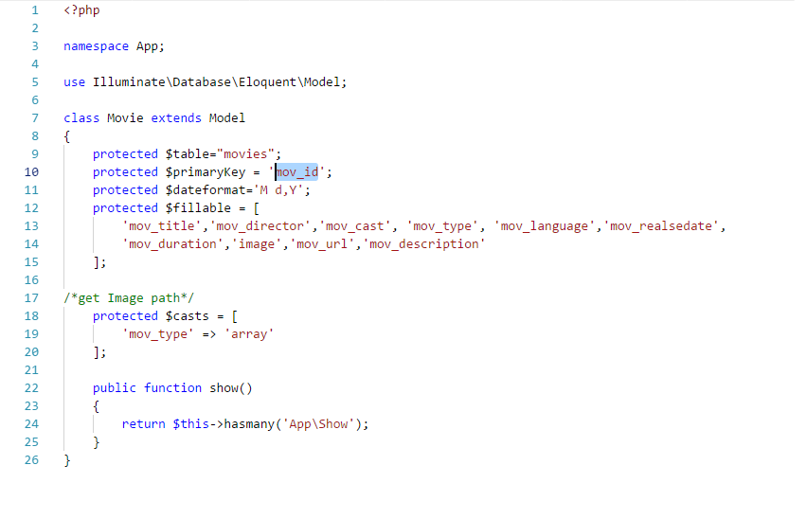

Fig: movie model

1. Show Model

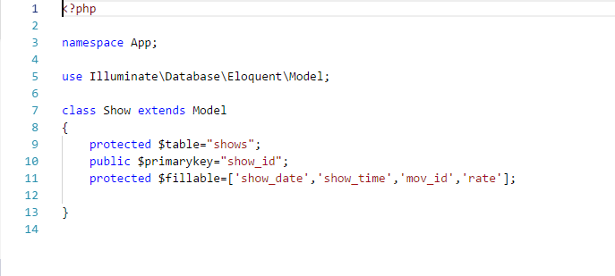

Booking Model

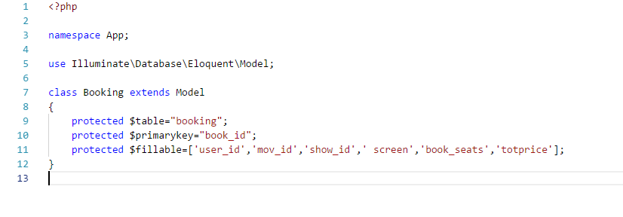

V) Screen Model

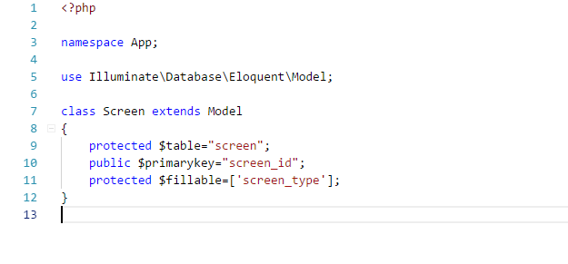

Vi)Hall Model

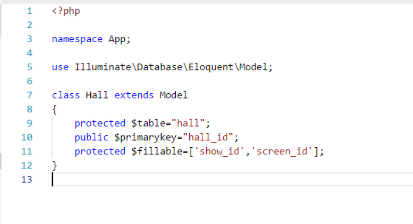

**Controller**

1. User Controller

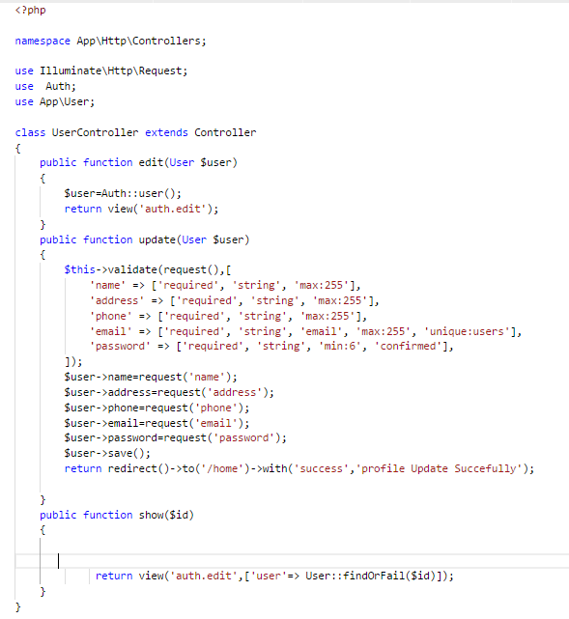

Ii) Movie Controller

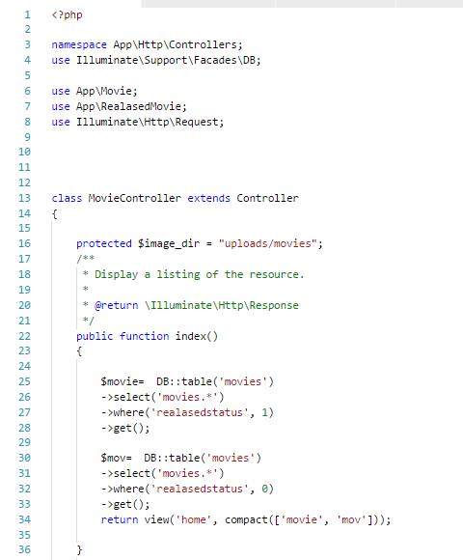

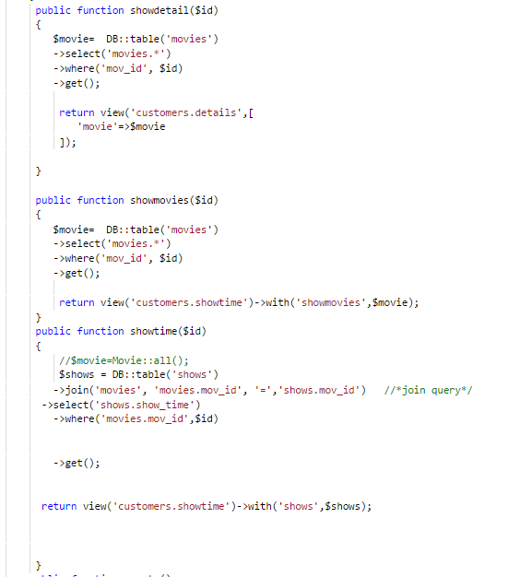

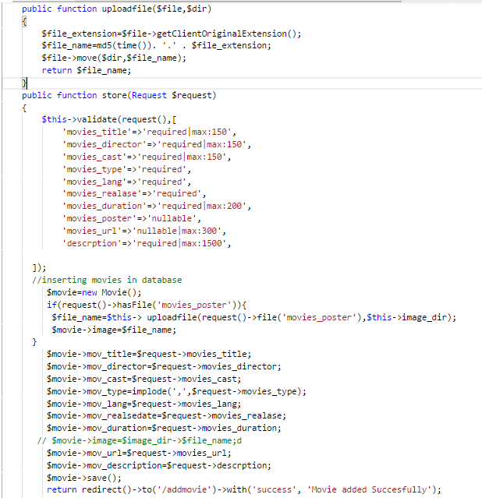

1. Delete Movie

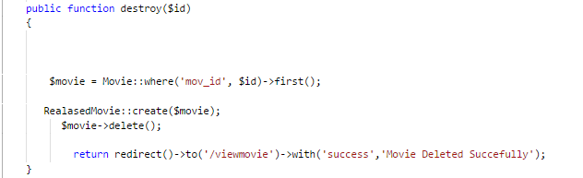

1. Show Controller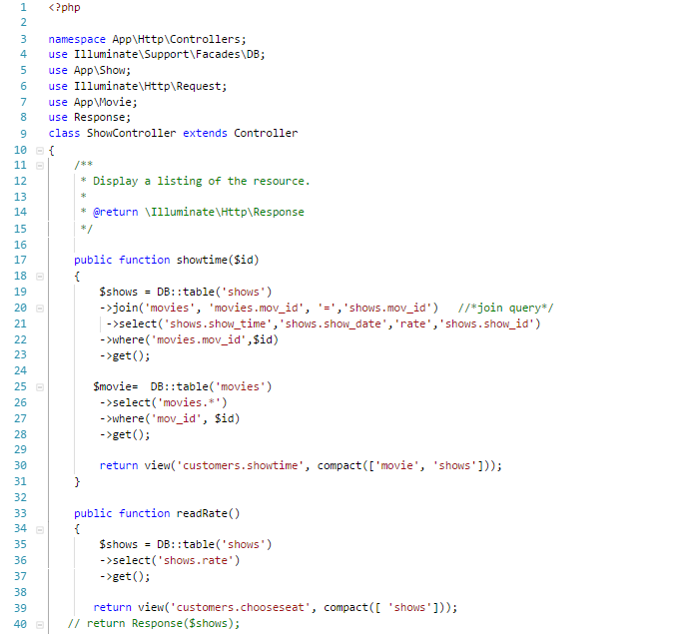

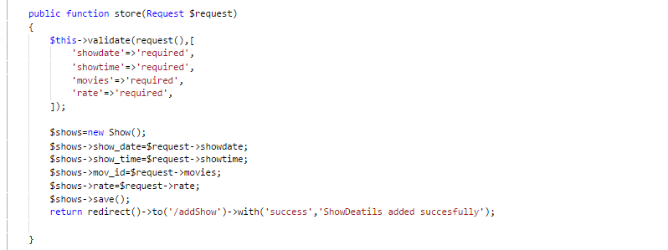

1. Seat Controller

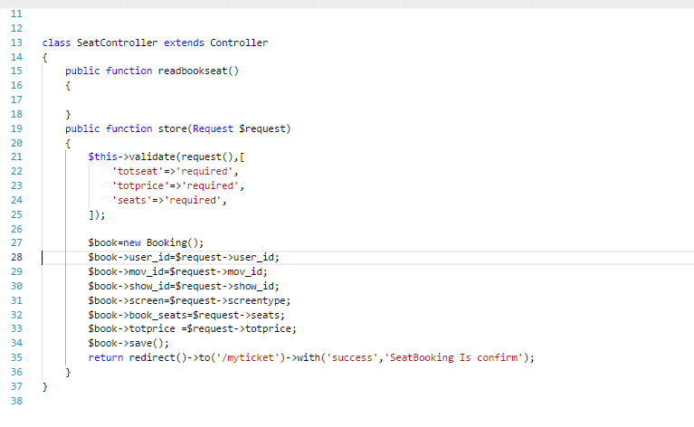

1. Ticket Controller

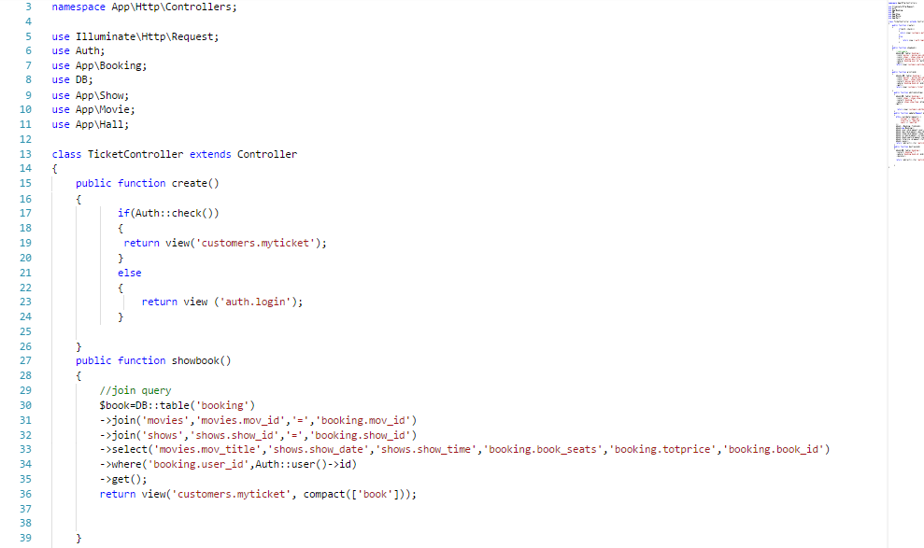

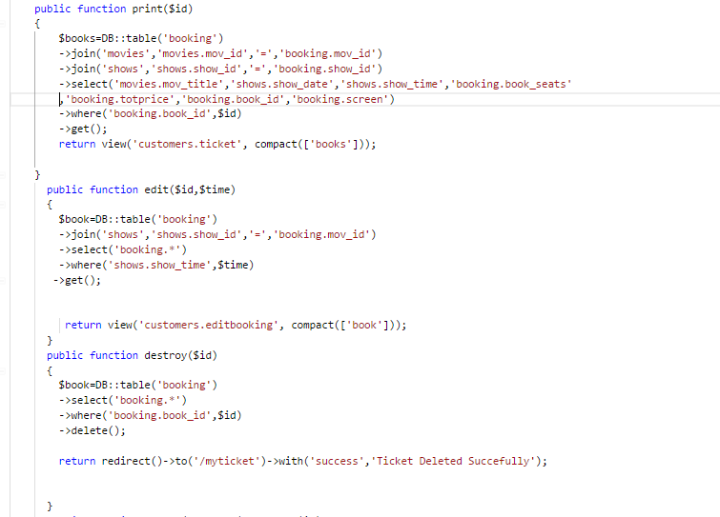

1. Hall Controller

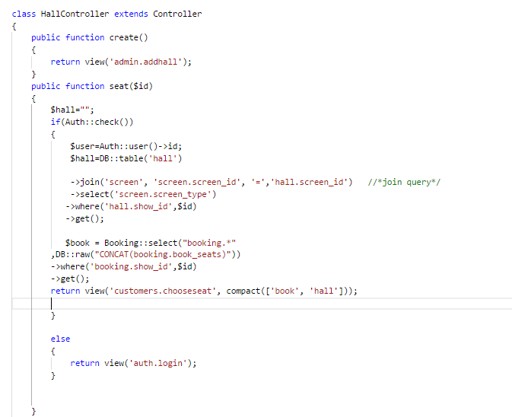

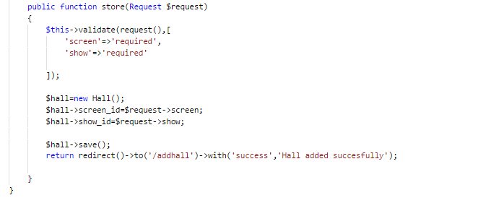

Routes

